Wrestling Stars We've Lost In 2022 - Wrestling Inc.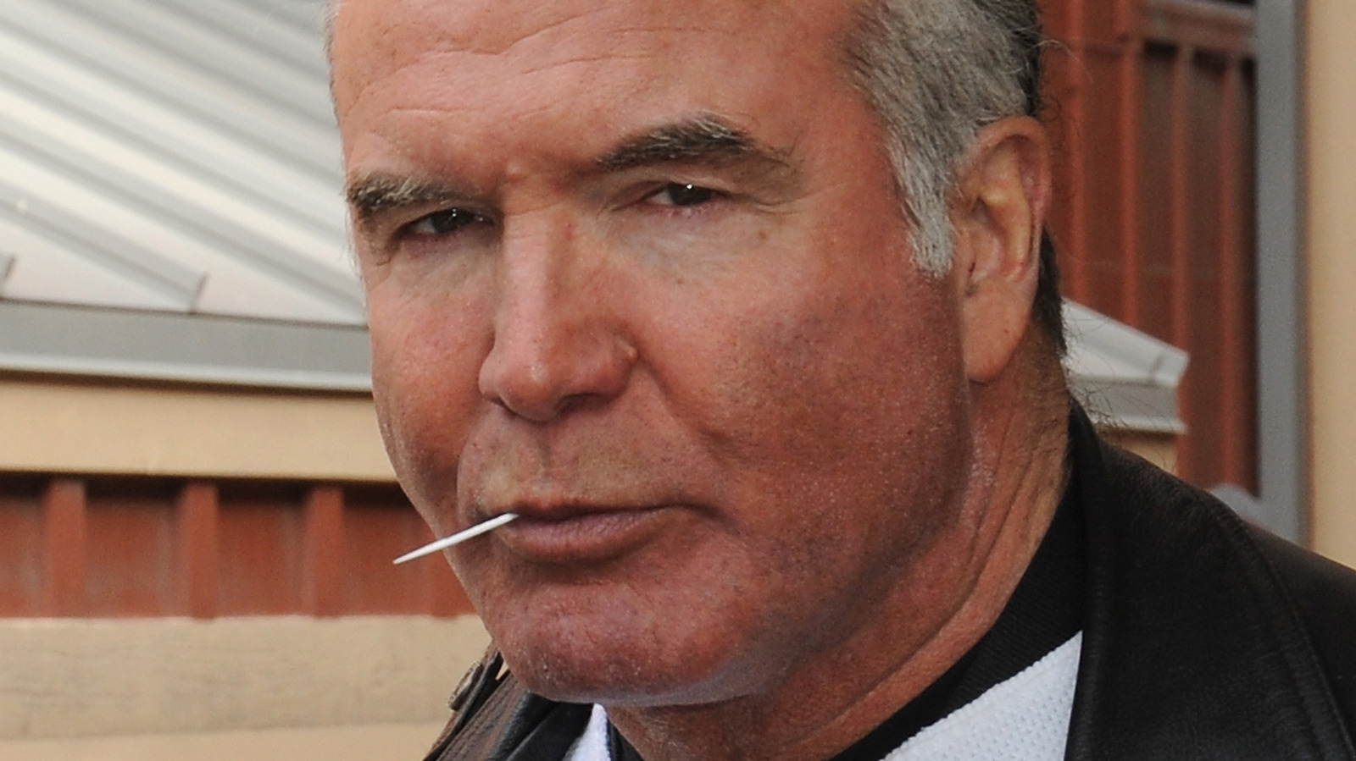  
  
<https://www.wrestlinginc.com/1068080/wrestling-stars-weve-lost-in-2022/>  
  
  
  
  
Take On me #Octave Challenge - Valentina Batta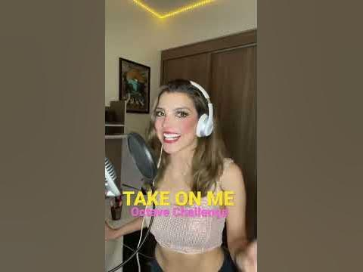  
  
<https://youtube.com/shorts/39ux3amrBJ8?feature=share>  
  
  
  
  
What people think is hard on guitar VS what actually is hard #shorts #classicalguitar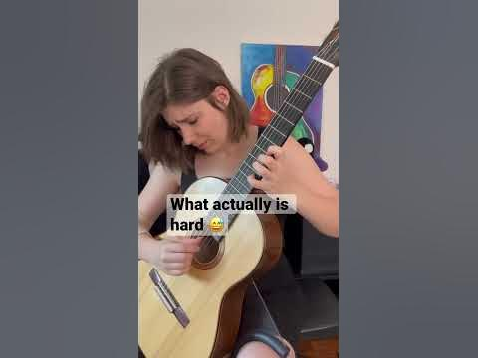  
  
<https://youtube.com/shorts/J-YS2SuHJvE?feature=share>  
  
  
  
  
This Transformation 😳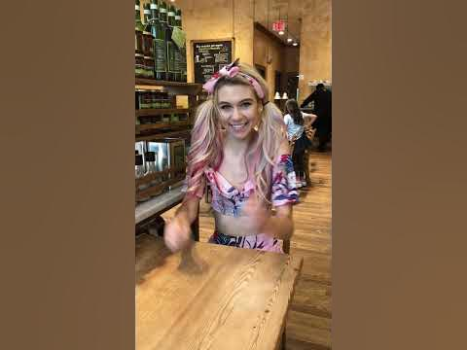  
  
<https://youtube.com/shorts/wRycBi7De14?feature=share>  
  
  
  
  
MAN IN THE BOX (@aliceinchains short cover) #shorts #cover #grunge  
  
<https://youtube.com/shorts/b-DWYTU5TcU?feature=share>  
  
  
  
  
Does Kurt Angle Really Like Milk? 🥛🤔#shorts #funny #kurtangle #wweshorts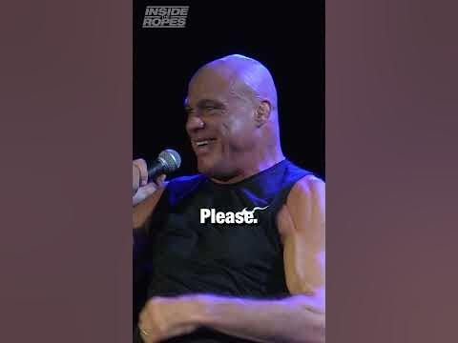  
  
<https://youtube.com/shorts/REEFbYKYhsM?feature=share>  
  
  
  
  
Best Interview Question Ever - Steven Spielberg "Thank you for that."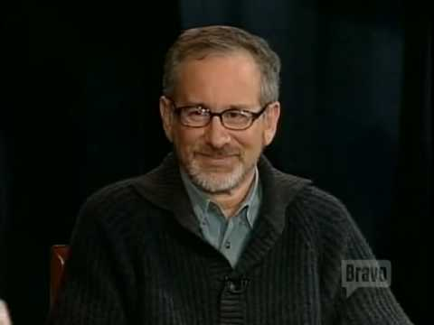  
  
<https://youtu.be/ZspOEa1CP4A>  
  
  
  
  
Woody Harrelson surprises 98 year old veteran with dream come true moment #shorts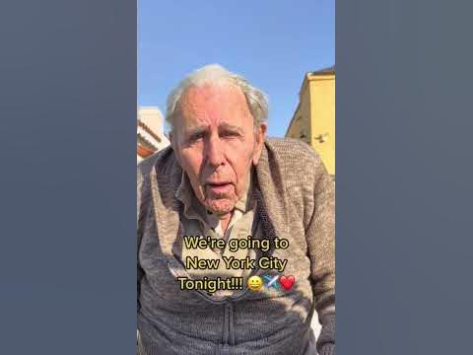  
  
<https://youtube.com/shorts/3syYg8PeIzM?feature=share>  
  
  
  
  
TRUTH BOMB: Jon Stewart DROPS Facts On Covid Origins; Makes Colbert Uncomfortable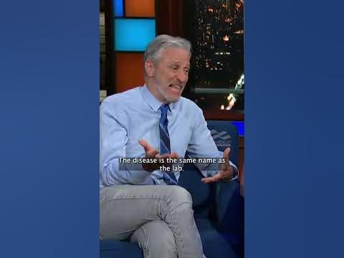  
  
<https://youtube.com/shorts/sNXN0BUM9P0?feature=share>  
  
  
  
  
Radiohead - Paranoid Android (Super Mario 64 Remix)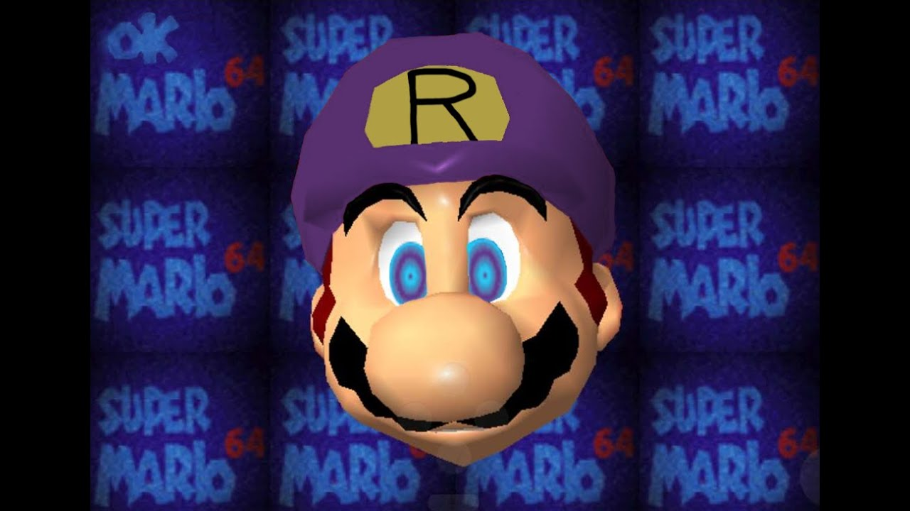  
  
<https://youtu.be/jv6ZUABZczc>  
  
  
  
  
How I Fake having a Rhythm Guitar live (as a bassist).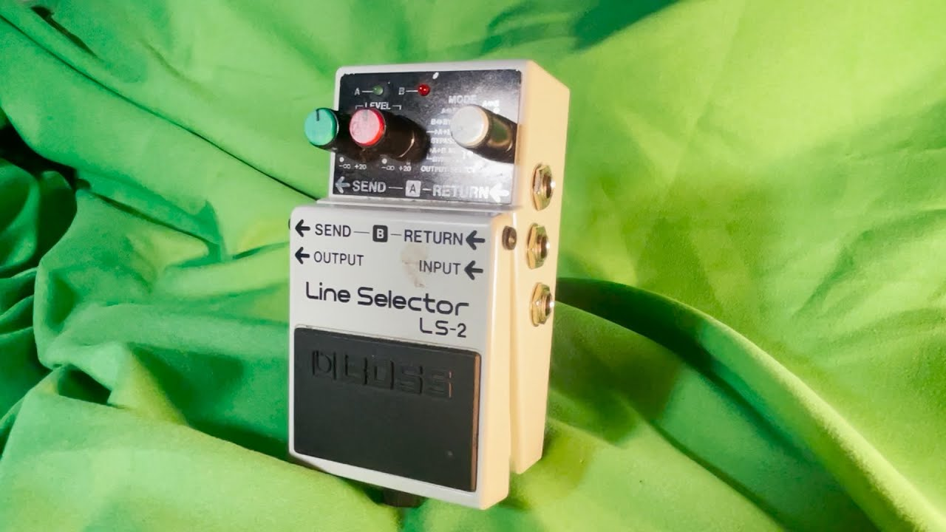  
  
<https://youtu.be/7rZIyWzu5yw>  
  
  
  
  
I Was A Successful Musician Because I Had Achieved What I Wanted To Achieve | Dave Grohl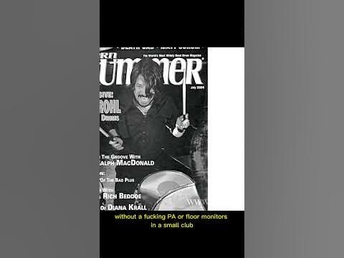  
  
<https://youtube.com/shorts/2gpzNffrXwQ?feature=share>  
  
  
  
  
Whole Lotta Love (#shorts cover)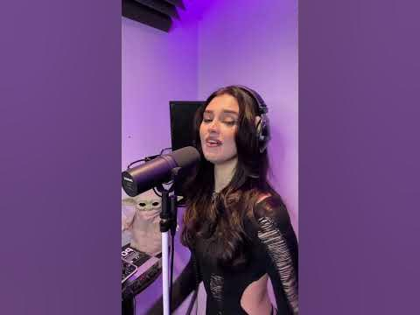  
  
<https://youtube.com/shorts/Td0NuUSe3Y4?feature=share>  
  
  
  
  
Dave Grohl Vs. Kurt Cobain - The Difference - Foo Fighters Vs. Nirvana #shorts #rockstar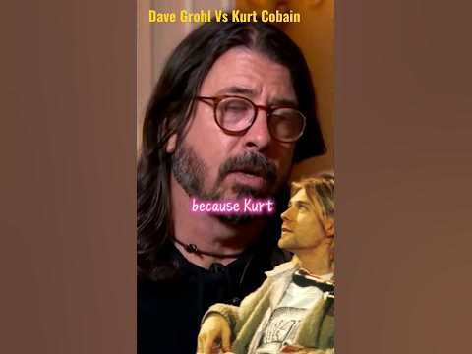  
  
<https://youtube.com/shorts/Tuf1_-hGsbQ?feature=share>  
  
  
  
  
The Rock meets The nWo: No Way Out 2002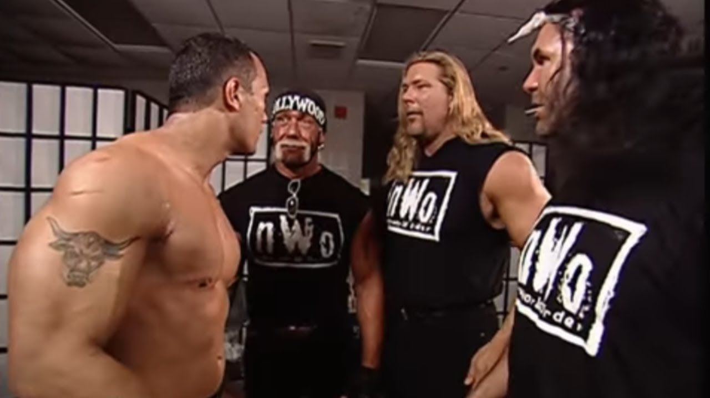  
  
<https://youtu.be/jojld3toWoc>  
  
  
  
  
Courtney Love's GUILT Towards Kurt Cobain's Death \*\*CRINGE ALERT\*\* #rockstar #shorts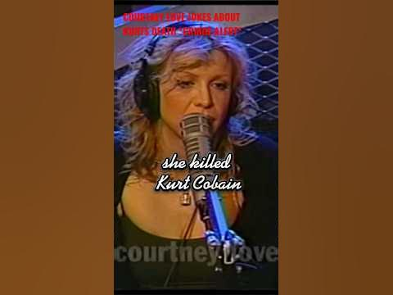  
  
<https://youtube.com/shorts/XdhnMZPtSsg?feature=share>  
  
  
  
  
Dirt by Alice in Chains but with the Super Mario 64 soundfont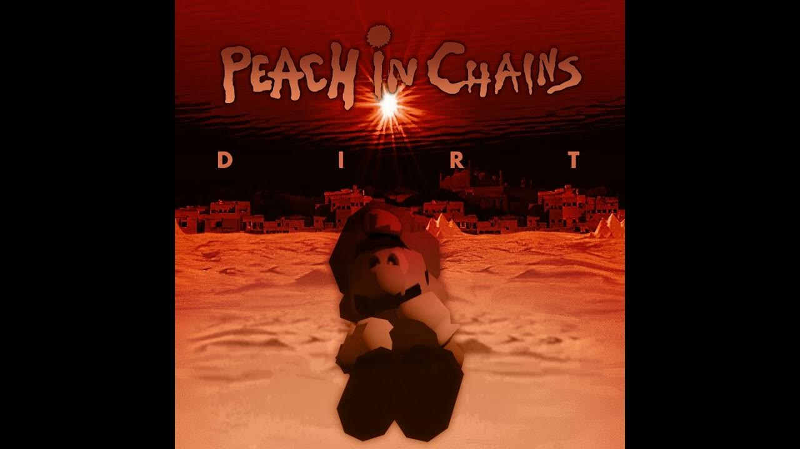  
  
<https://youtu.be/rWF3gjHE5Mw>  
  
  
  
  
Alice In Chains - Would? (LIVE New York 1993) #Shorts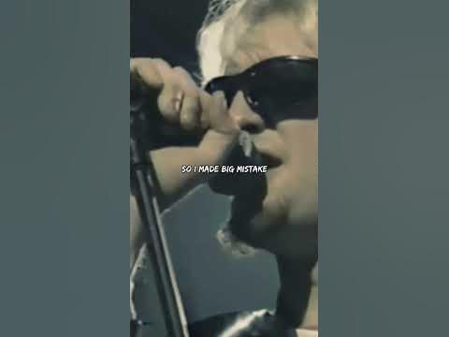  
  
<https://youtube.com/shorts/CdUR7lqhGb4?feature=share>  
  
  
  
  
How Drummers Knock on Doors 2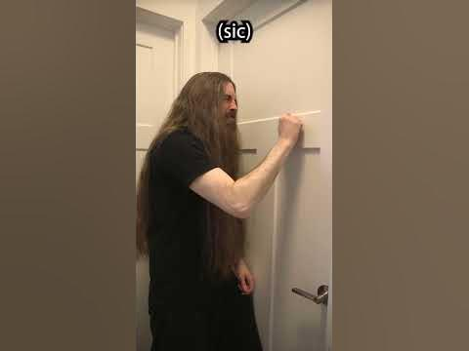  
  
<https://youtube.com/shorts/eAbVzs2Xddc?feature=share>  
  
  
  
  
Lars Ulrich Gets Hit In The Head With A Gym BAll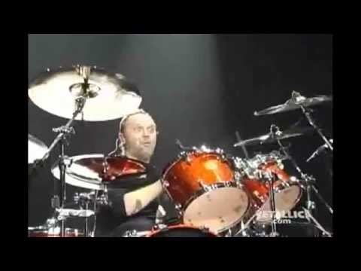  
  
<https://youtu.be/NZ209j81gJQ>  
  
  
  
  
To Those of You Who Are Doubting Your Path (As a Software Engineer)  
  
<https://youtu.be/myiFcP34pBc>  
  
  
  
  
Vegeta proves he isn't a total geek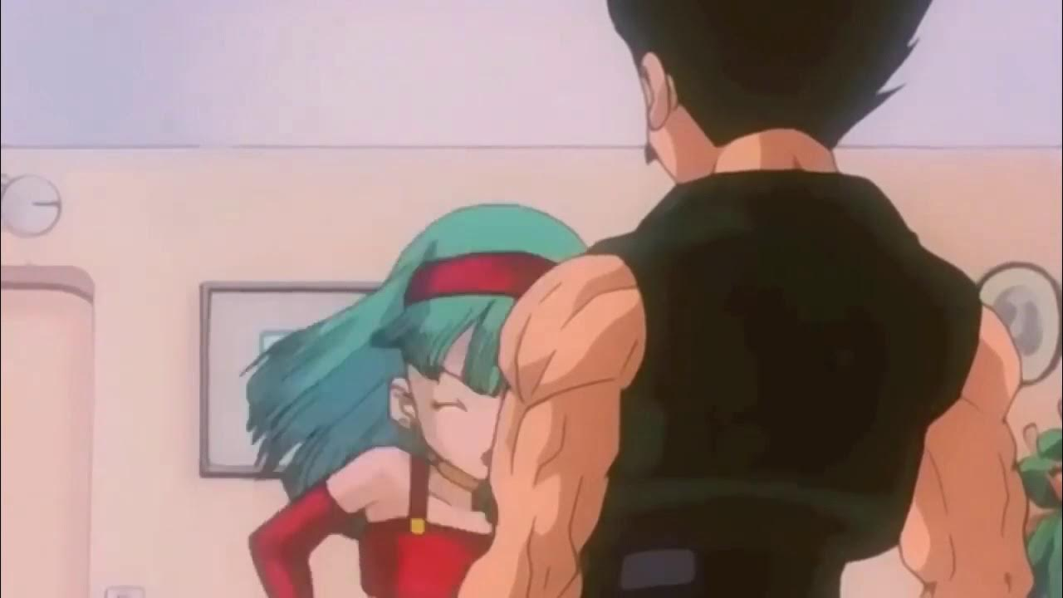  
  
<https://youtu.be/3OW8l-tDujE>  
  
  
  
  
Best Cry Ever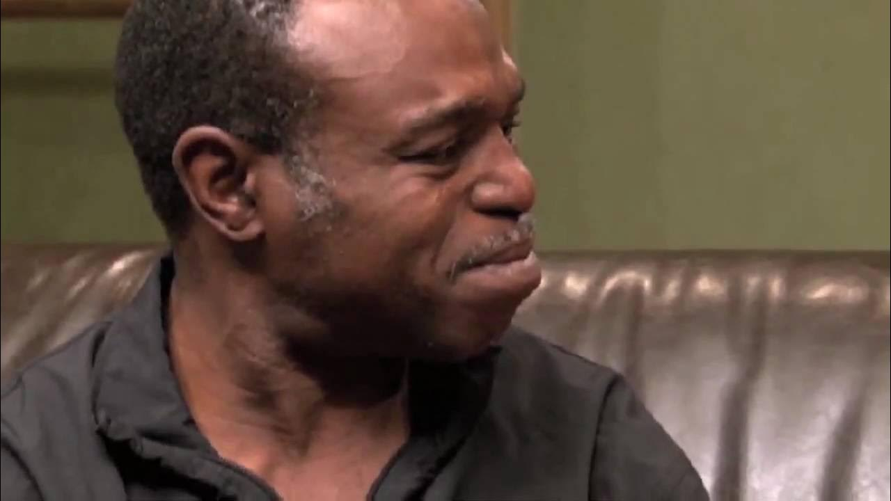  
  
<https://youtu.be/ee925OTFBCA>  
  
  
  
  
Christopher Nolan Reveals What Helped Him Develop As A Writer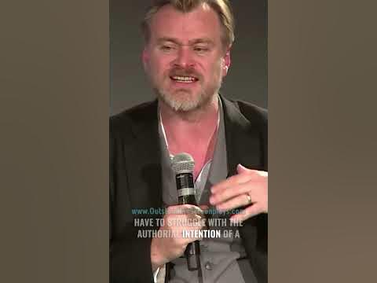  
  
<https://youtube.com/shorts/aS7HBcFm0lA?feature=share>  
  
  
  
  
Chris Rock | Stop Telling Your Kids That They Are Special #shorts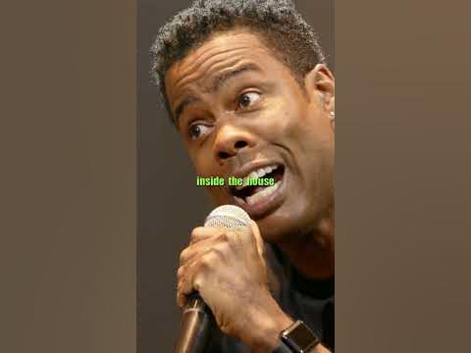  
  
<https://youtube.com/shorts/np-JAKzes8Q?feature=share>  
  
  
  
  
David Benoit Wants To Wrestle As Chris Benoit Jr.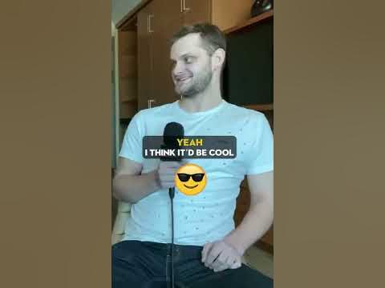  
  
<https://youtube.com/shorts/dLBasSQgn_c?feature=share>  
  
  
  
  
Toad Jackson - Billie Jean (cover)  
  
<https://youtu.be/OsbtBNNWRVw>  
  
  
  
  
John Lennon - Let it A, Let it B, let it C, Let it D..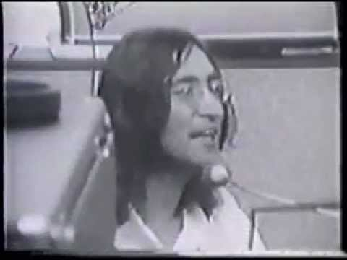  
  
<https://youtu.be/3E0MaIAYQ5Y>  
  
  
  
  
John Cena - The Story Behind 'You Can't See Me' 😂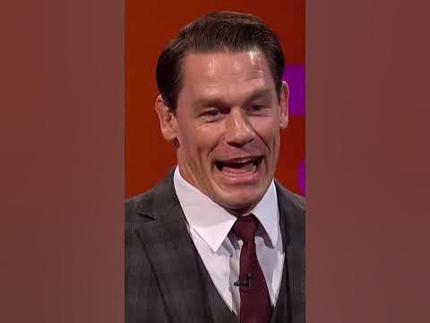  
  
<https://youtube.com/shorts/SBGDZhn3ibk?feature=share>  
  
  
  
  
BROCK LESNAR On His Legacy and His Philosophy On Success #shorts #brocklesnar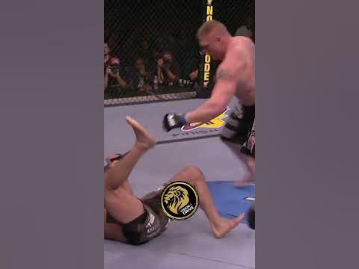  
  
<https://youtube.com/shorts/3COToLyQ-3U?feature=share>  
  
  
  
  
POV: you ordered chop suey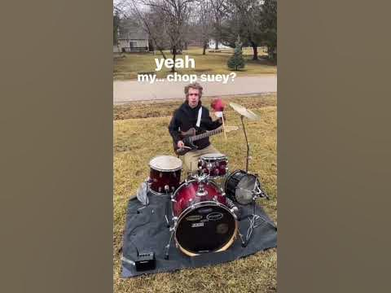  
  
<https://youtube.com/shorts/Axkh_5-uFR4?feature=share>  
  
  
  
  
The Rock Makes Fun Of Triple H Face 😂😂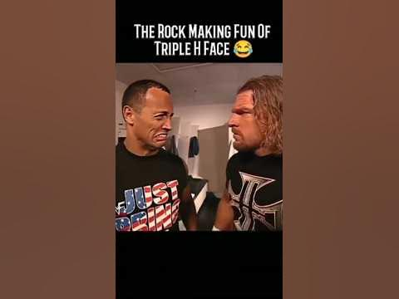  
  
<https://youtube.com/shorts/49iBLKoRF4s?feature=share>  
  
  
  
  
Adrenaline in.....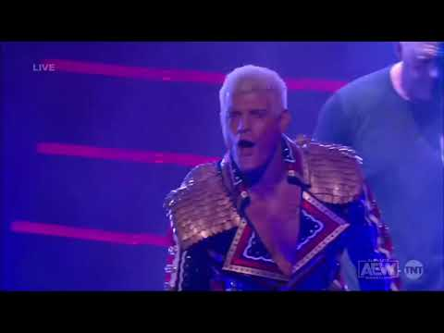  
  
<https://youtu.be/djxZOfYF-G8>  
  
  
  
  
How To Spot A Counterfeit Bill With Nacho Varga | Better Call Saul #shorts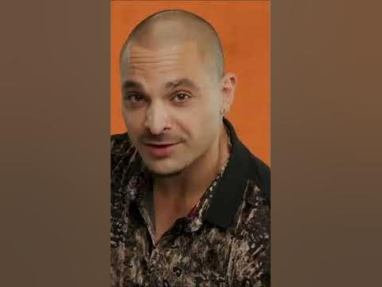  
  
<https://youtube.com/shorts/DNu8phhTiPc?feature=share>  
  
  
  
  
Freddie Mercury's Insane Partying | Forgotten History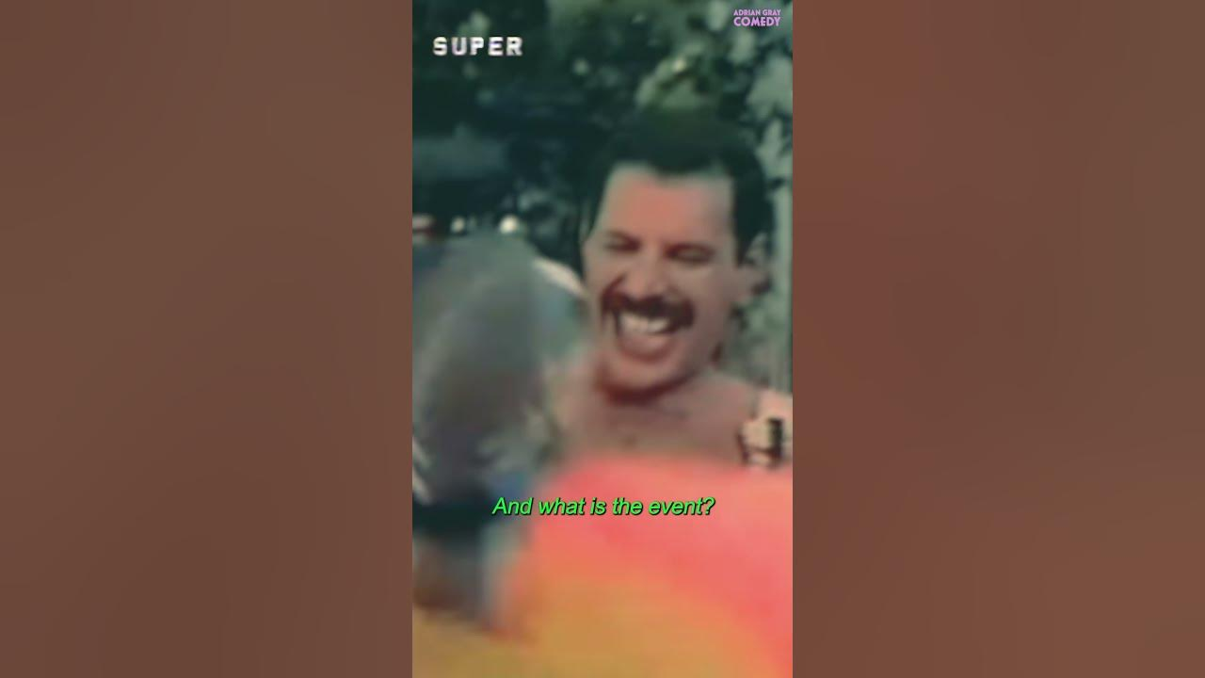  
  
<https://youtube.com/shorts/bEBPNRrLLWI?feature=share>  
  
  
  
  
Country roads let'sa go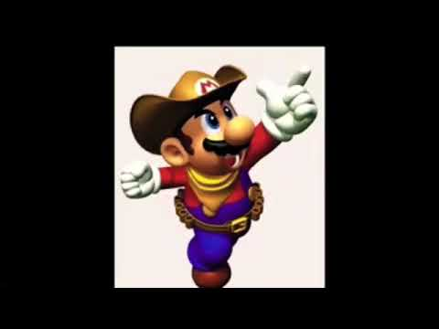  
  
<https://youtu.be/sOc8SrT8jbk>  
  
  
  
  
Former Nirvana and Soundgarden Guitarist on Working With Kurt Cobain - Jason Everman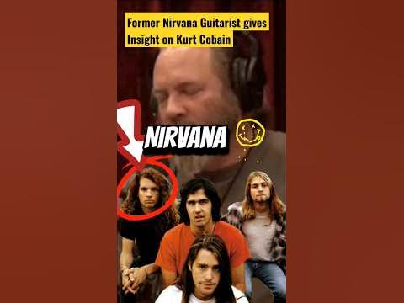  
  
<https://youtube.com/shorts/ur-GiMeWsg0?feature=share>  
  
  
  
  
WWE champion John Cena speaks Mandarin, professes love for Lao Gan Ma  
  
<https://youtu.be/LNuwgbxQe-M>  
  
  
  
  
Mike Shinoda Tells The Real Story Behind 'Breaking The Habit': "It's not about addiction"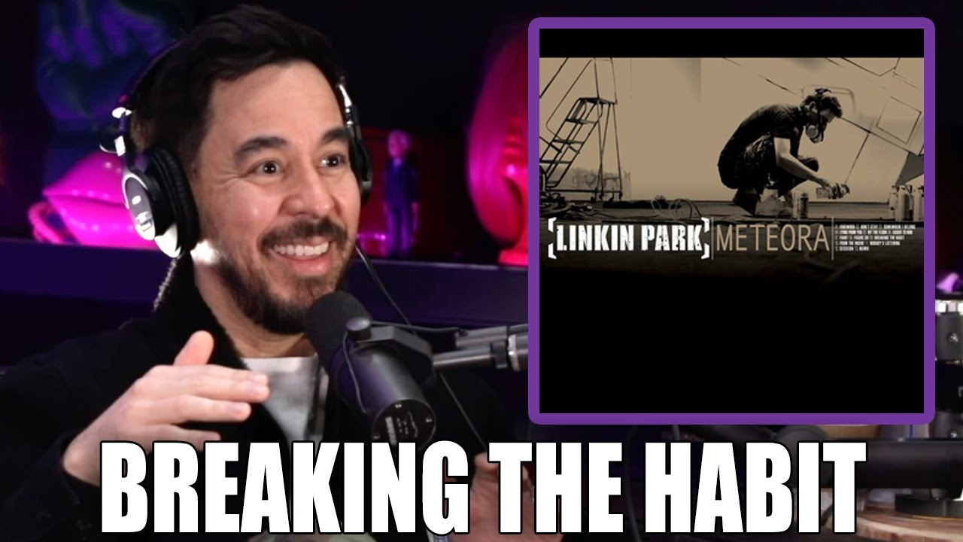  
  
<https://youtu.be/Ff92-41pO9o>  
  
  
  
  
When you don't know a single chord, but you need to impress new friends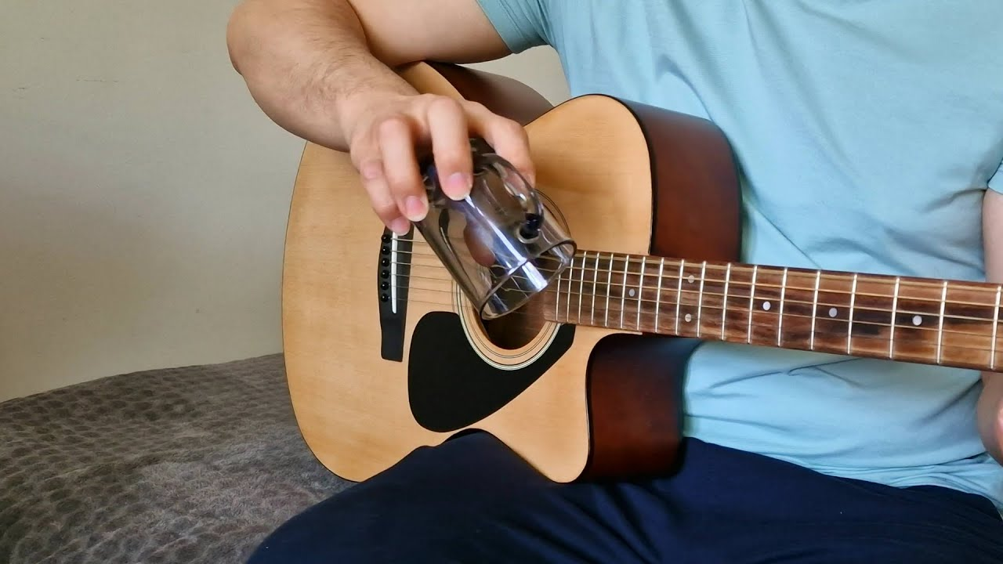  
  
<https://youtu.be/peHSF19v9Dk>  
  
  
  
  
Jack Black and his Iconic Saxaboom Jam 😎 (Shorts Version \*Repost\*) #jackblack #thetonightshow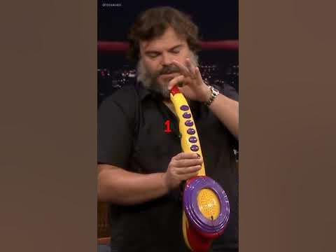  
  
<https://youtube.com/shorts/8hKaZP7uNt0?feature=share>  
  
  
  
  
Daft Punk- Pee Is Stored In The Balls (ft. The Weeknd) | Grammys Performance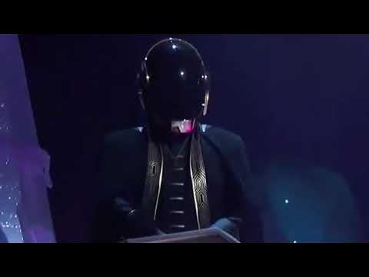  
  
<https://youtu.be/to52Sqi4gY8>  
  
  
  
  
Nirvana - Rape Me (Live at the Paramount 1991) HD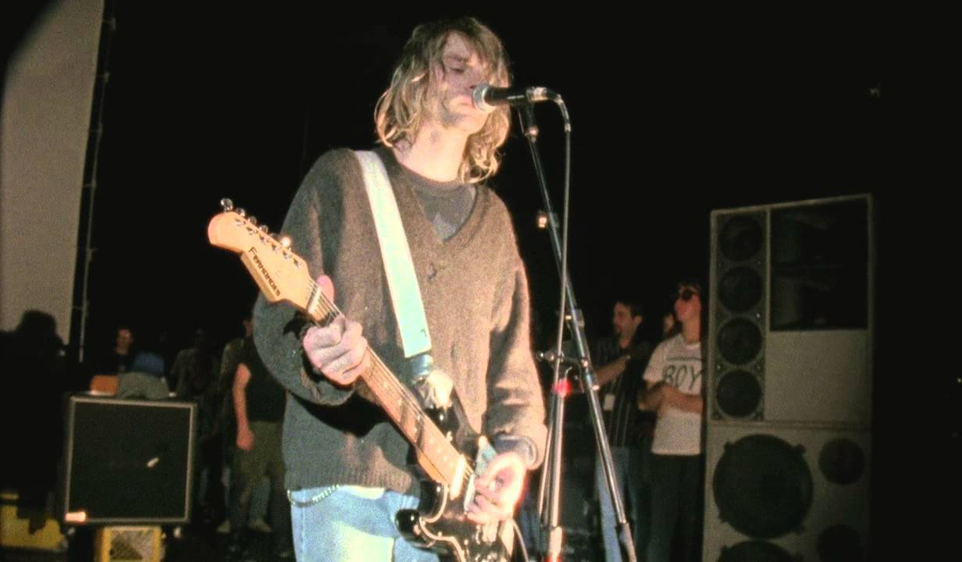  
  
<https://youtu.be/Ax0C6rlo-54>  
  
  
  
  
How to Pronounce ( ͡° ͜ʖ ͡°)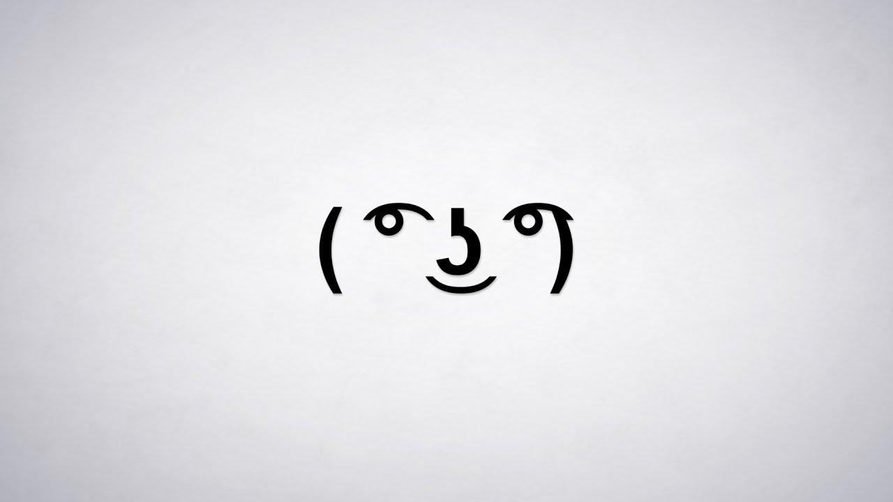  
  
<https://youtu.be/AVN-wjJxOSc>  
  
  
  
  
Referee Secretly Signals To Snoop Dogg To Hit The People's Elbow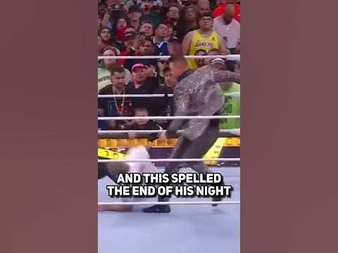  
  
<https://youtube.com/shorts/XDGBKemWpug?feature=share>  
  
  
  
  
We surprised our wedding guests with our wedding entrance | WWE Wrestling Wedding Reception Entrance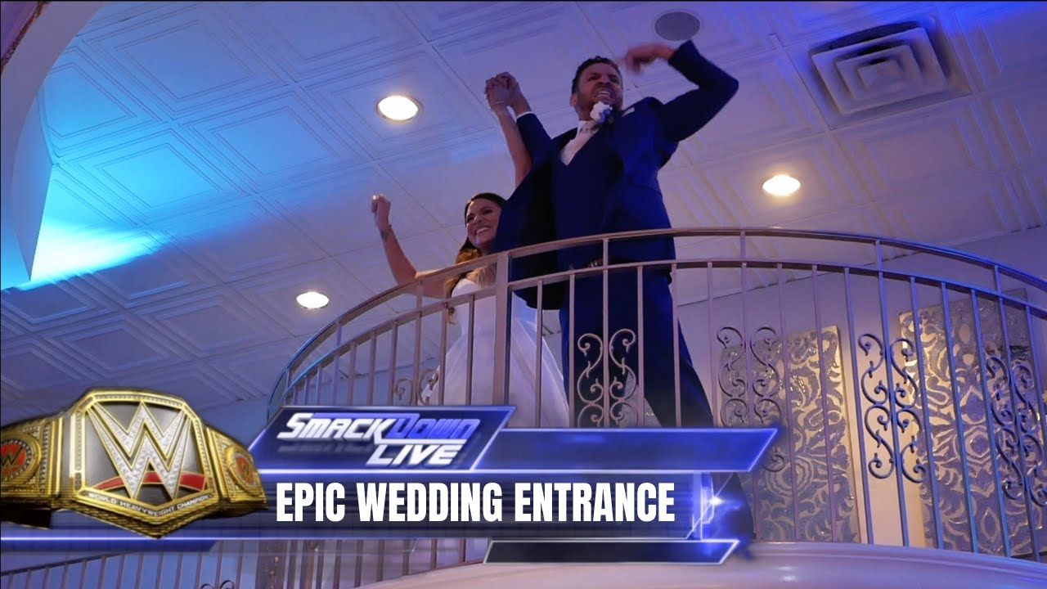  
  
<https://youtu.be/auNSM9RWDIE>  
  
  
  
  
I’ll never get a happy ending :(  
  
<https://youtube.com/shorts/03M6TjFUmDE?feature=share>  
  
  
  
  
John Cena Faked a Bathroom Break So Brodus Clay Could Have His Wrestlemania 28 Moment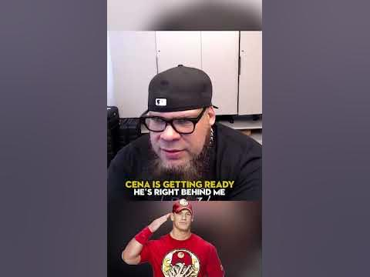  
  
<https://youtube.com/shorts/b8BU0nVSuRs?feature=share>  
  
  
  
  
Chris Rock - How not to get your ass kicked by the police!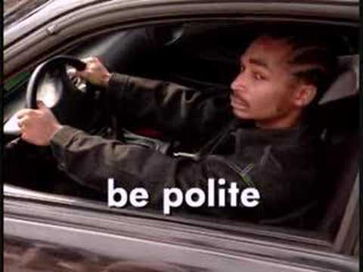  
  
<https://youtu.be/uj0mtxXEGE8>  
  
  
  
  
How WWE Uses Fake Crowd Noise When Fans Don't React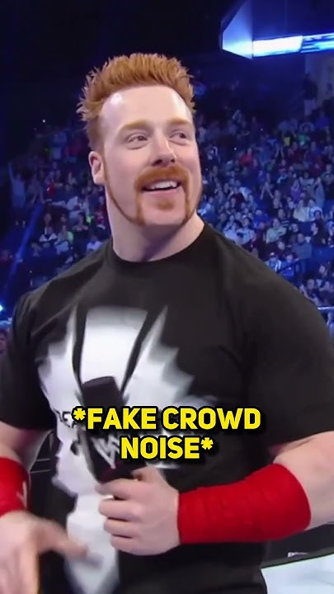  
  
<https://youtube.com/shorts/eRFF7Qnx3dU?feature=share>  
  
  
  
  
‌you've been hit by a smooth gamecube intro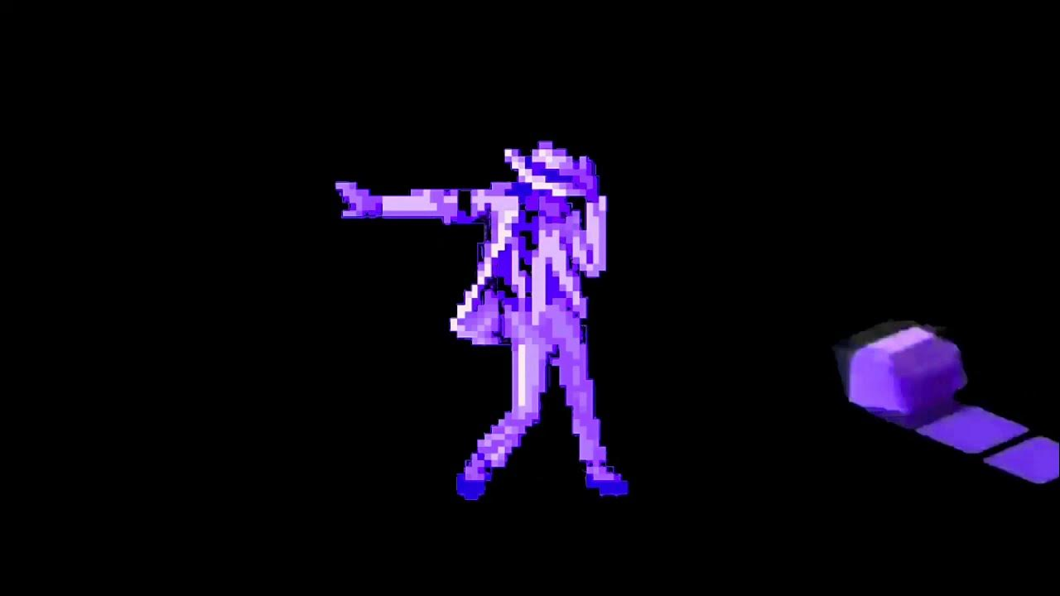  
  
<https://youtu.be/IGcvDQfOBG0>  
  
  
  
  
South Park's Theme, But Matt and Trey forgot to pitch their voices up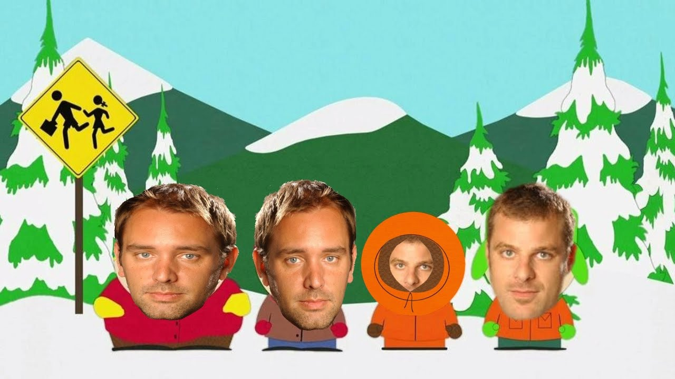  
  
<https://youtu.be/wpNhuMRh5NY>  
  
  
  
  
A Navy SEAL Explains Why You Should End A Shower With Cold Water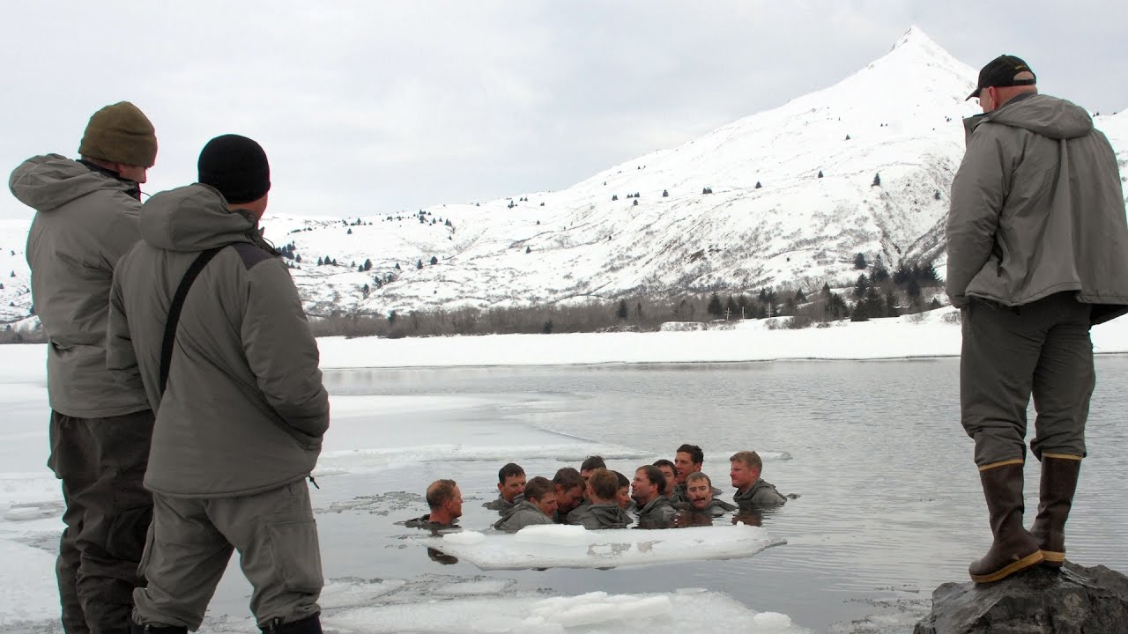  
  
<https://youtu.be/bUvZNpFLtGs>  
  
  
  
  
Sneak Peek: The Match That Started "Stone Cold" Steve Austin and Bret Hart Epic Rivalry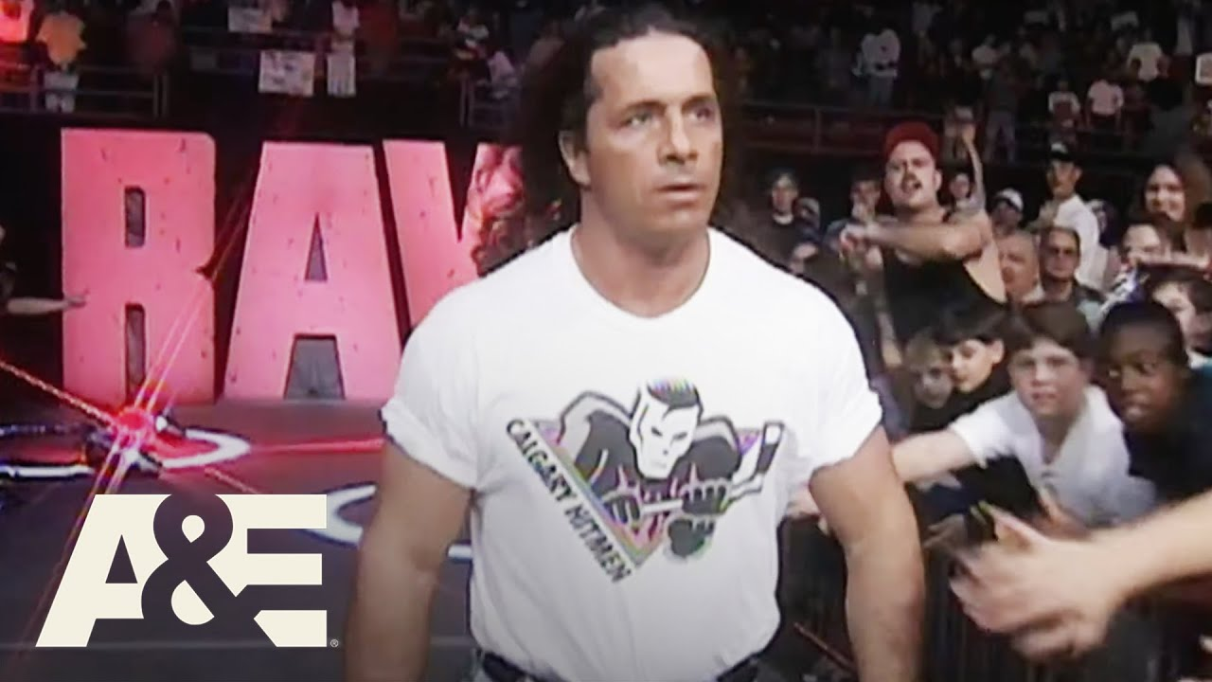  
  
<https://youtu.be/Tdoq9frqTi0>  
  
  
  
  
Bret Hart DESTROYS Rumours Of The Montreal Screwjob Being A Work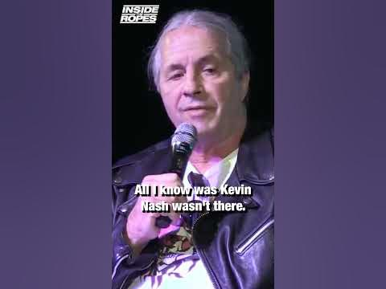  
  
<https://youtube.com/shorts/IKmb3TOufDk?feature=share>  
  
  
  
  
How WWE Use Clever Camera Tricks To Edit Out Botches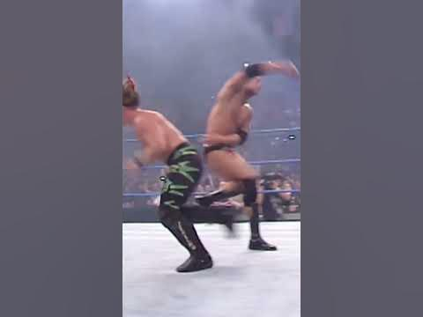  
  
<https://youtube.com/shorts/EEivjfy7KkU?feature=share>  
  
  
  
  
HBK Forced To Improvise After Kevin Nash Tears His Quad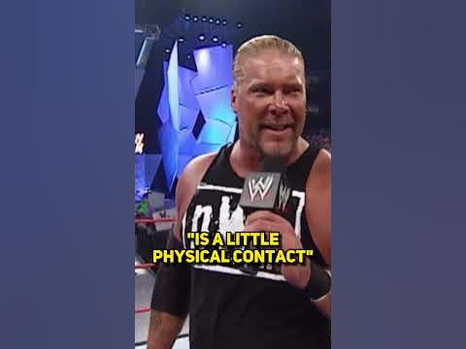  
  
<https://youtube.com/shorts/ilXqNe3ELhU?feature=share>  
  
  
  
  
Super Mario Bros Condom Trumpet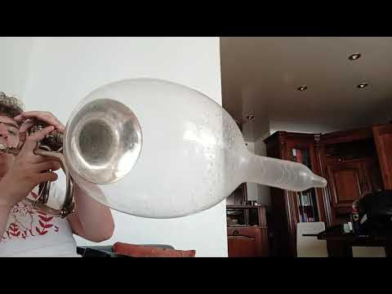  
  
<https://youtu.be/YidRNvL535I>  
  
  
  
  
I can’t believe this worked!! 😅 #shorts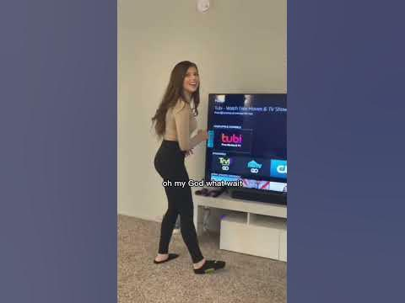  
  
<https://youtube.com/shorts/vskDJEGgn7w?feature=share>  
  
  
  
  
Country Roads, Mario.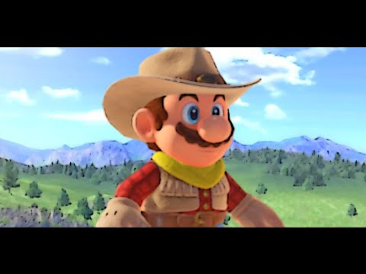  
  
<https://youtu.be/dwivMZfjpks>  
  
  
  
  
Brock Lesnar Drinks Kurt Angle's Milk And Instantly Regrets It | WWE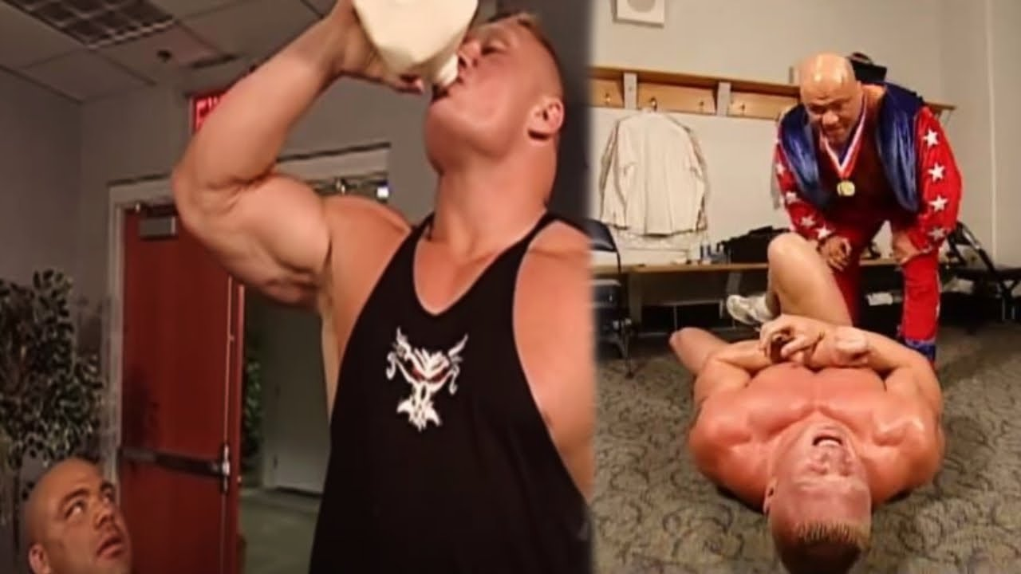  
  
<https://youtu.be/JsWaG3aRdak>  
  
  
  
  
Sax-a-boom, the myth busted!  
  
<https://youtu.be/9MCN_7jpYig>  
  
  
  
  
Did We just Find The Best Guitarist Ever? 🤯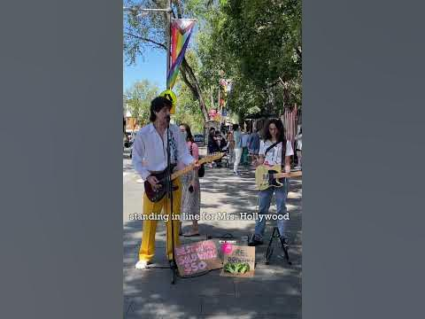  
  
<https://youtube.com/shorts/q-nCGI4c0C0?feature=share>  
  
  
  
  
When Kurt Cobain kissed Dave Grohl after hearing his demo... #shorts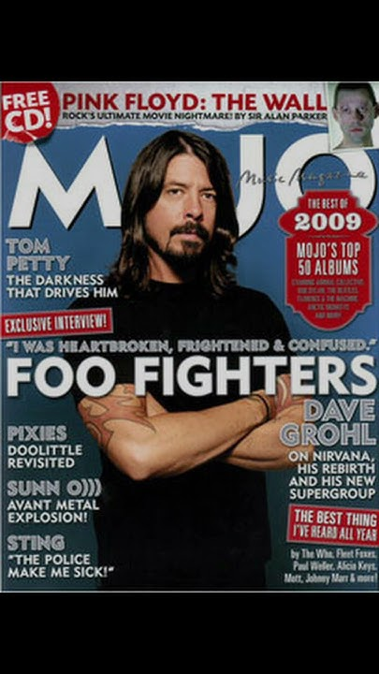  
  
<https://youtube.com/shorts/QP0uQ6Lc8T8?feature=share>  
  
  
  
  
This Wrestler Had No Idea He Was Scripted To Win The Title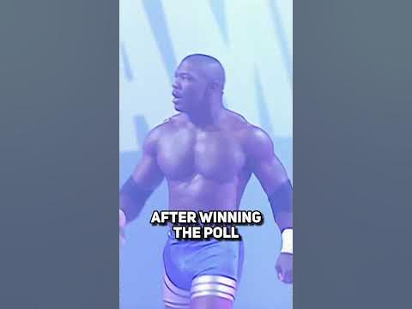  
  
<https://youtube.com/shorts/Y72hX2c3CeA?feature=share>  
  
  
  
  
YOU ASKED FOR IT! #shorts  
  
<https://youtube.com/shorts/ZtCDA61C7hw?feature=share>  
  
  
  
  
Her Spine Decompressed!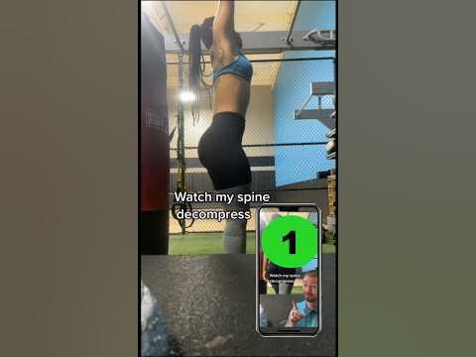  
  
<https://youtube.com/shorts/TlEgiQkuXT4?feature=share>  
  
  
  
  
Dan Castellaneta On Voicing Homer Simpson | Late Night with Conan O’Brien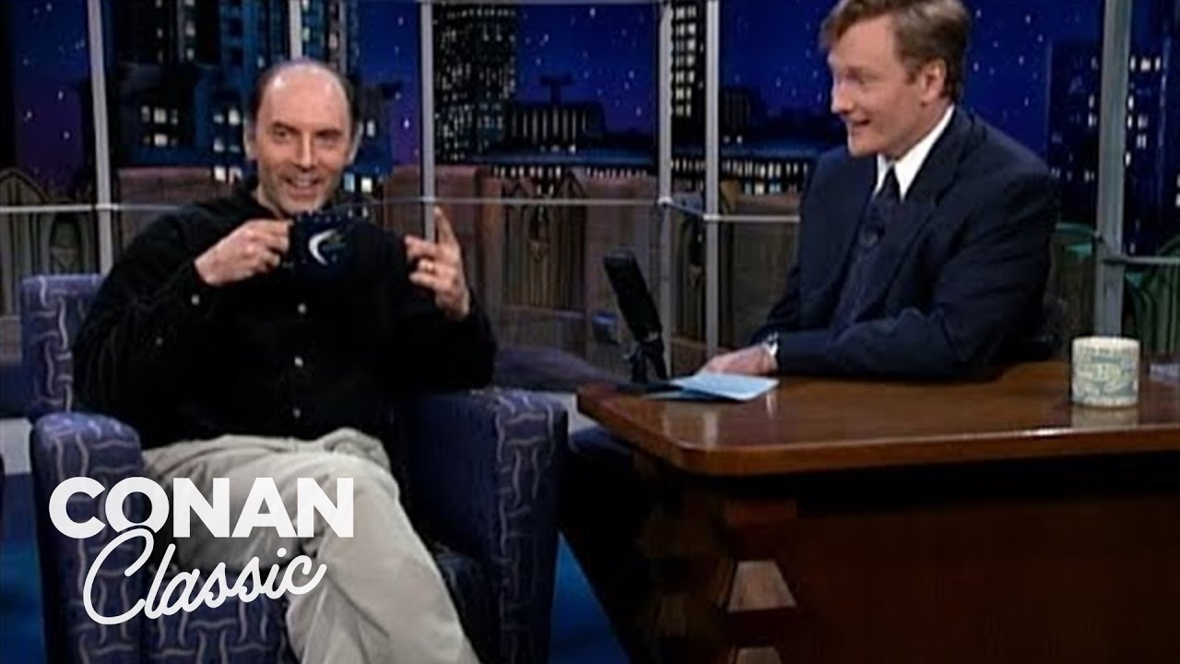  
  
<https://youtu.be/Eo0HfbJvPEU>  
  
  
  
  
The REAL REASON Ryan Gosling Agreed to Play Ken in the Barbie Movie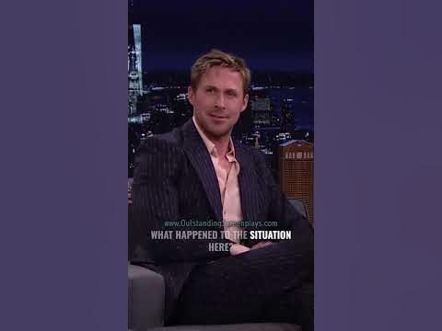  
  
<https://youtube.com/shorts/0LwfjyNTXHA?feature=share>  
  
  
  
  
Harry Shearer & Dan Castellaneta Do Iconic Voices From The Simpsons | Late Night with Conan O’Brien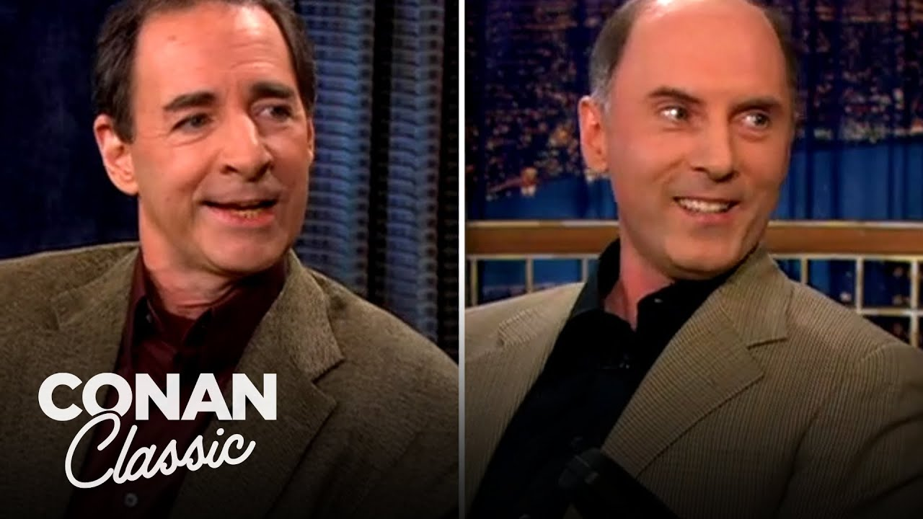  
  
<https://youtu.be/QuWAZmBnuEk>  
  
  
  
  
can i put my balls in yo jaws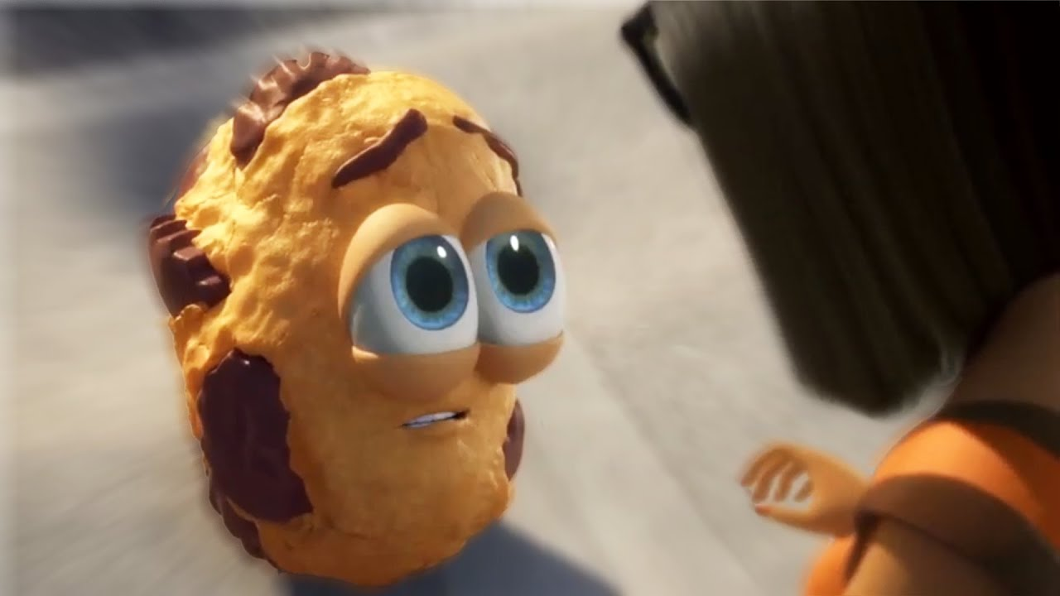  
  
<https://youtu.be/v6kgDtUqGRM>  
  
  
  
  
How We'll Play Donkey Kong In The Future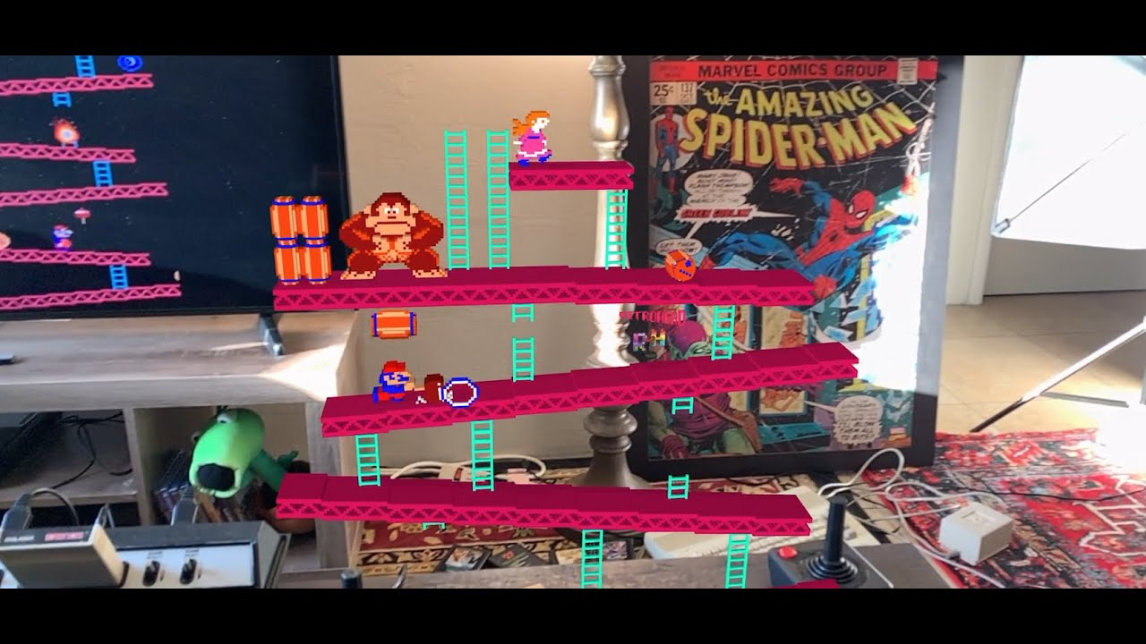  
  
<https://youtu.be/U26NCNonWrY>  
  
  
  
  
The Secret Of How Wrestlers Bleed From The Mouth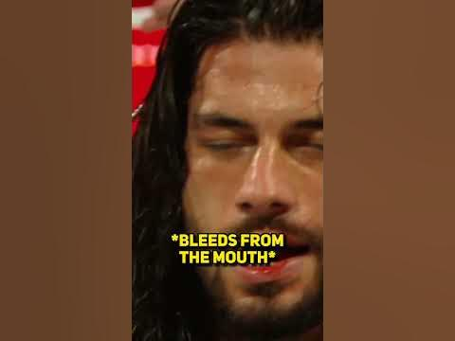  
  
<https://youtube.com/shorts/g-mZBcGK_C4?feature=share>  
  
  
  
  
This Is The Reason EMINEM Doesn't Like CHRISTINA AGUILERA😂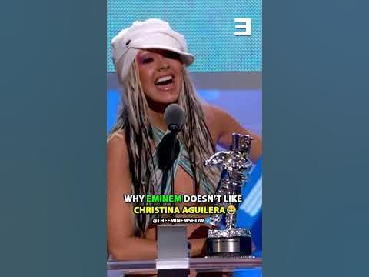  
  
<https://youtube.com/shorts/92xAKxWhVrw?feature=share>  
  
  
  
  
Drums are Never Animated Correctly...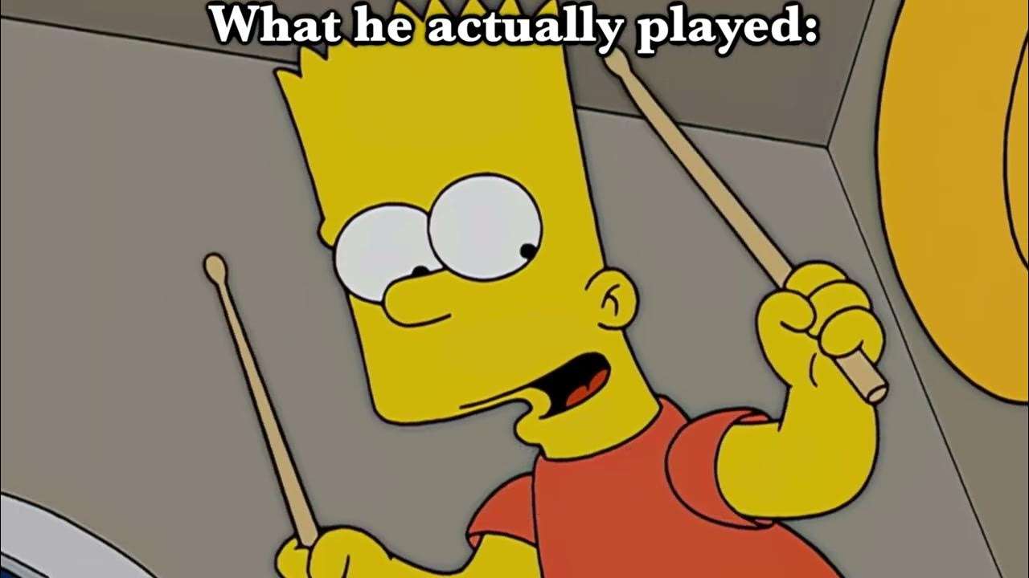  
  
<https://youtu.be/IpB80fcHxV4>  
  
  
  
  
Spring Boot Testing | Writing JUnit Tests using JUnit and Mockito | Java Techie  
  
<https://youtu.be/kXhYu939_5s>  
  
  
  
  
This System Of A Down Riff Sounds Better on Acoustic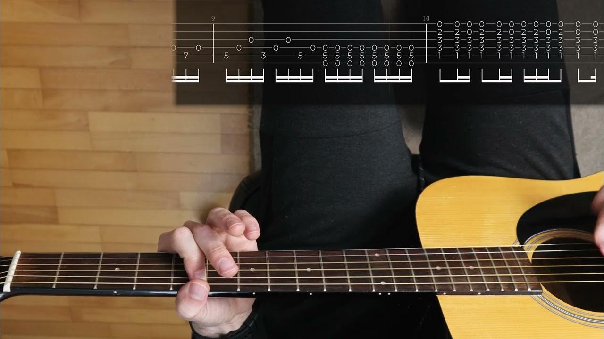  
  
<https://youtu.be/lw5FNNQ5me8>  
  
  
  
  
Michael gets angry on stage  
  
<https://youtube.com/shorts/3iscI18CTWE?feature=share>  
  
  
  
  
Brock Lesnar on being nervous around crowds. Many of us can relate to this.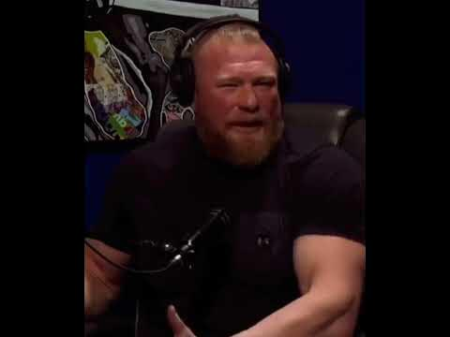  
  
<https://youtube.com/shorts/lUtDuHiY4X8?feature=share>  
  
  
  
  
going from cutscene graphics to in-game graphics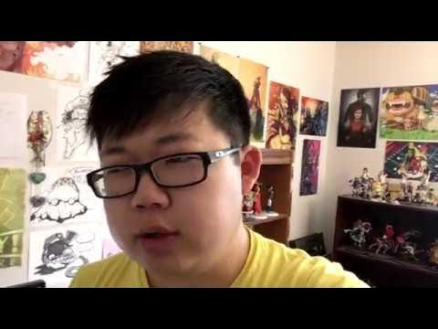  
  
<https://youtu.be/JnX42OHnuLA>  
  
  
  
  
Bret Hart's best athletic moves (70s–90s tribute)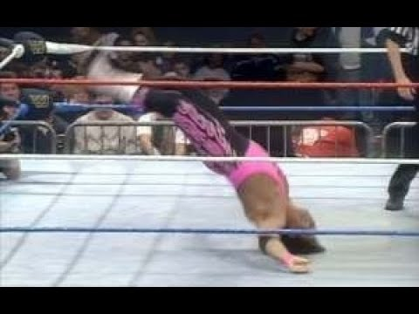  
  
<https://youtu.be/ejTAbP7oalg>  
  
  
  
  
This app makes Bass sound like a piano.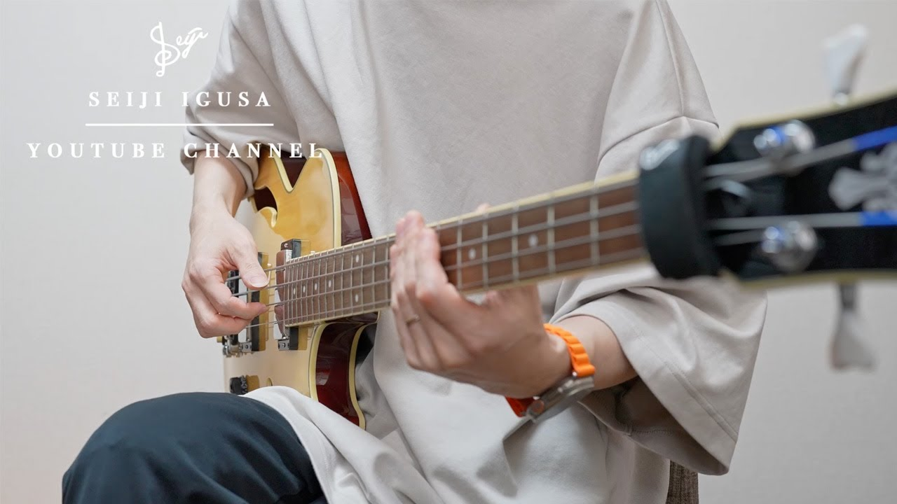  
  
<https://youtu.be/tRbQh1vzdJ0>  
  
  
  
  
This message plays every time my batteries run low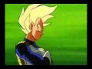  
  
<https://youtu.be/JMY2v_aeuSw>  
  
  
  
  
Heath Ledger & The Dark Knight Opening Scene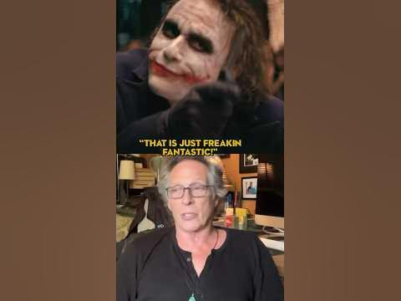  
  
<https://youtube.com/shorts/trSa7iUpqcg?feature=share>  
  
  
  
  
Heath Ledger & The Dark Knight Opening Scene  
  
<https://youtube.com/shorts/trSa7iUpqcg?feature=share>  
  
  
  
  
Guy gets mad at his rich girlfriend! 🤣 #shorts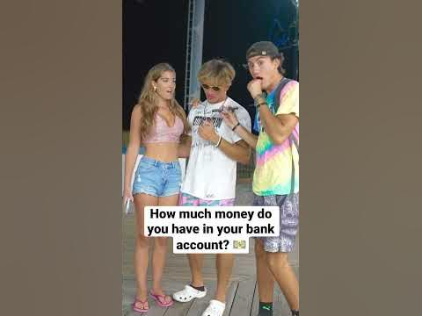  
  
<https://youtube.com/shorts/I6I6ZioR0C4?feature=share>  
  
  
  
  
michael jackson wrestling with carlito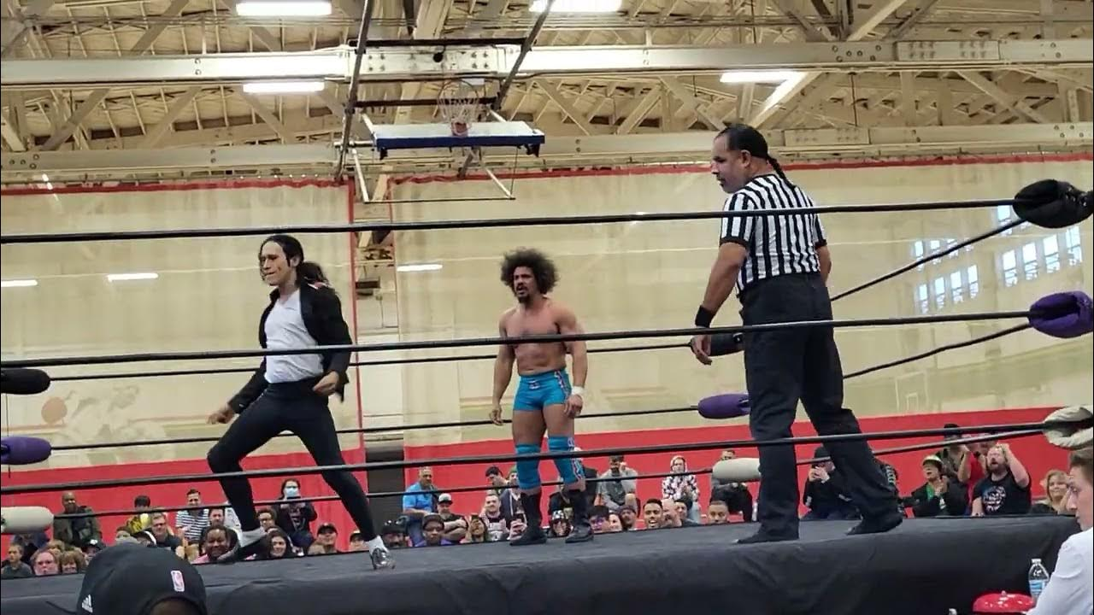  
  
<https://youtu.be/DiAE0TBbTNE>  
  
  
  
  
I am a surgeon but it speeds up when he says surgeon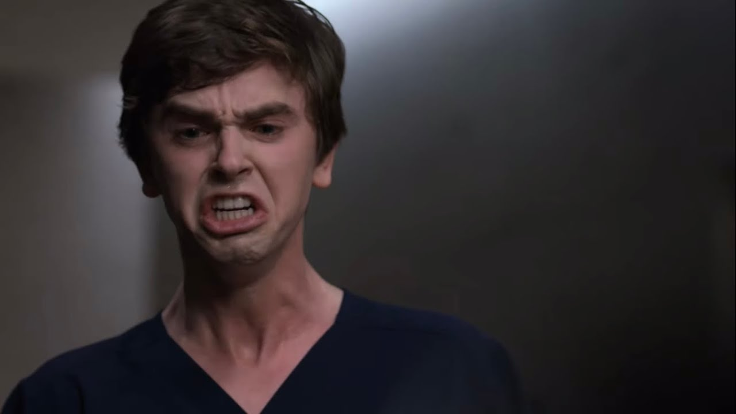  
  
<https://youtu.be/seJc5kIVY84>  
  
  
  
  
New Years Watch-Party: Nirvana [Kurt Cam]- 1993-12-13 - Seattle, WA - [Kurt Solo Cam/OpenMic Audio]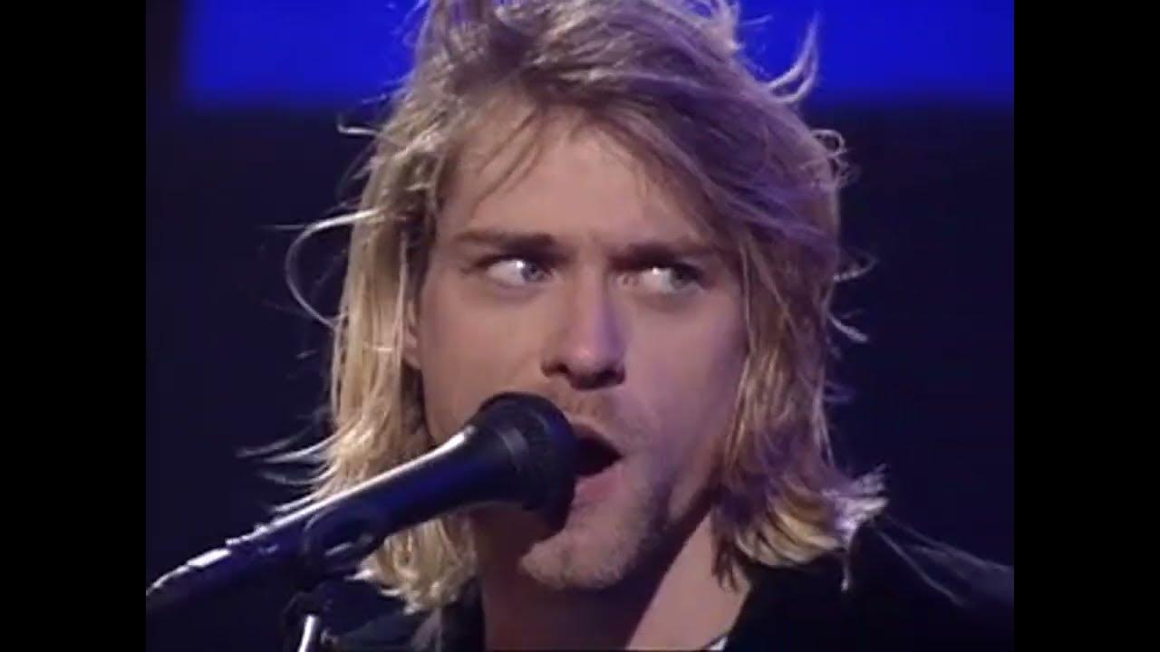  
  
<https://youtu.be/LwmKySGL68k>  
  
  
  
  
Crazy ECW Fan Chants At Batista And Big Show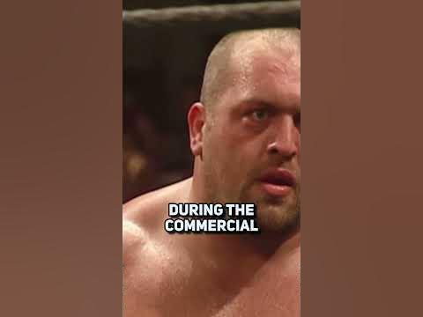  
  
<https://youtube.com/shorts/mbqnu0GTWUM?feature=share>  
  
  
  
  
Storyteller Tactics  
  
<https://pipdecks.com/pages/storyteller-tactics-card-deck>  
  
  
  
  
The NEW Wilson basketball is INSANE!!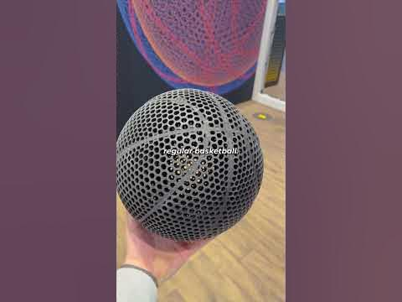  
  
<https://youtube.com/shorts/7Lsk8qiZ7pE?feature=share>  
  
  
  
  
The Rock Eats a Chicken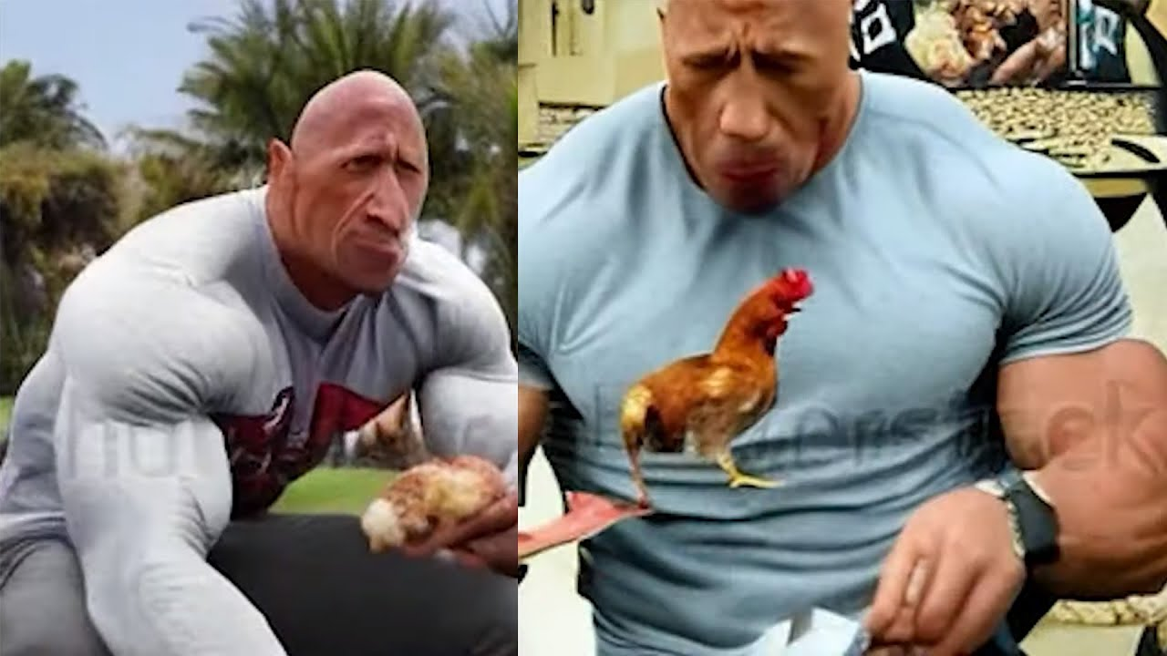  
  
<https://youtu.be/HyvHbHNNY2w>  
  
  
  
  
Street Performer Beats every Joker impersonator!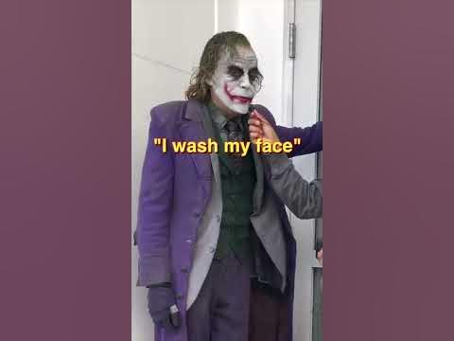  
  
<https://youtube.com/shorts/fyyQQ4i1YoQ?feature=share>  
  
  
  
  
Kurt Cobain & Krist Talk about the Beatles #Nirvana #thebeatles #shorts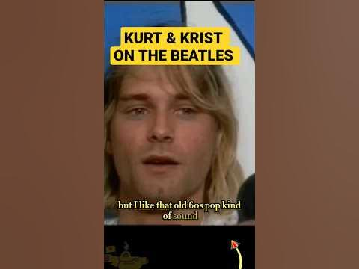  
  
<https://youtube.com/shorts/RVmYXKqlQUw?feature=share>  
  
  
  
  
Triple Wall Jump in Real Life? 😳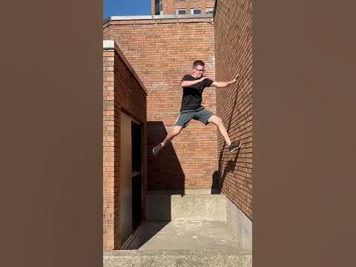  
  
<https://youtube.com/shorts/kiXYop0Cb00?feature=share>  
  
  
  
  
Aubrey Plaza says what all the interns want to say #aubreyplaza #memes #intern #internships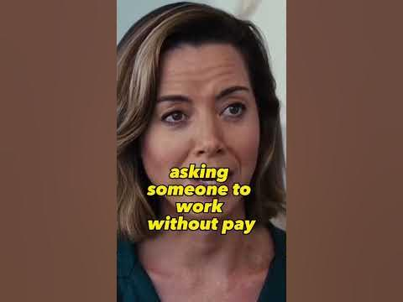  
  
<https://youtube.com/shorts/DYFwZtXijwc?feature=share>  
  
  
  
  
Living Colour “Cult of Personality” on the Stern Show (2016)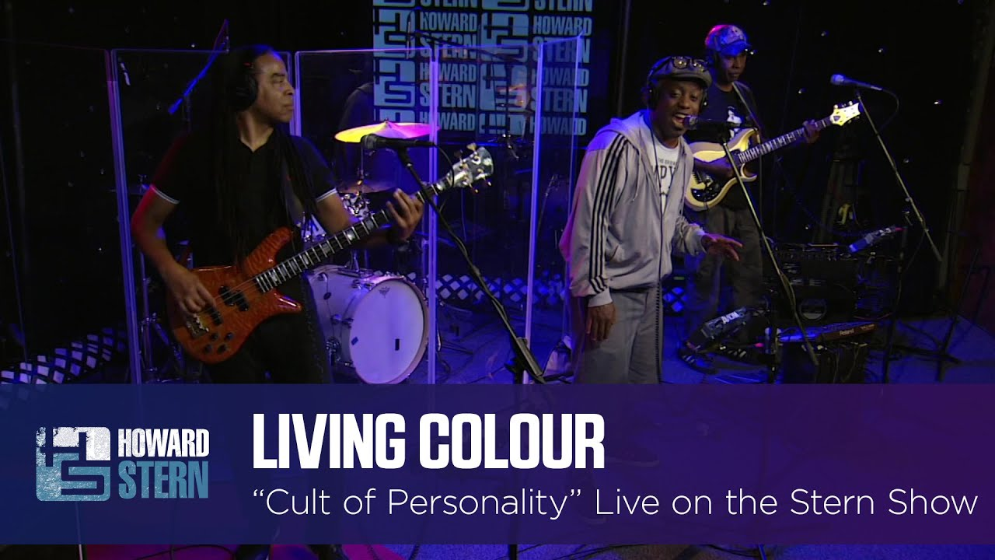  
  
<https://youtu.be/WJXHFNw3fSw>  
  
  
  
  
When they ask you why you aren’t married yet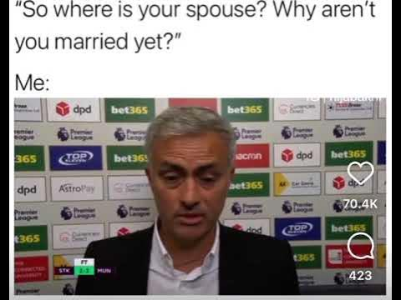  
  
<https://www.youtube.com/watch?v=EUogQ1os2as>  
  
  
  
  
Steel Panther Full Performance & Judges Comments | America's Got Talent 2023 S18E01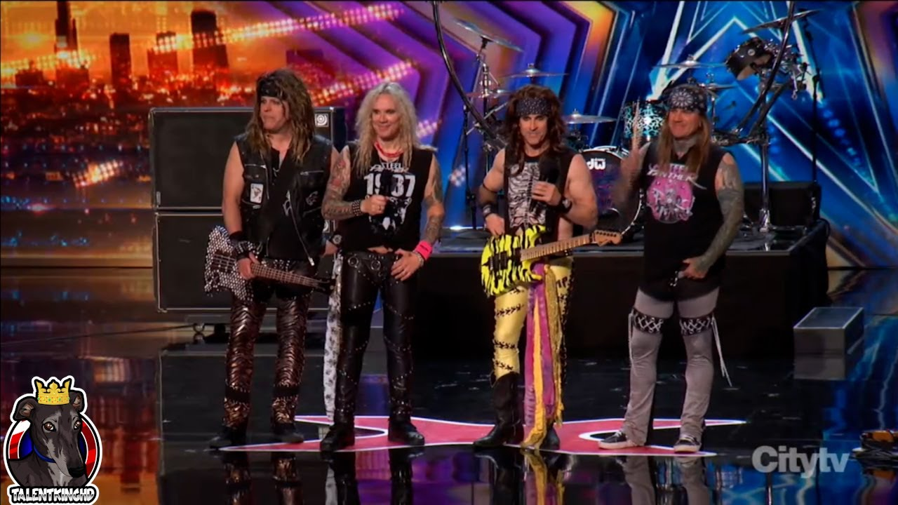  
  
<https://youtu.be/Pg8-L64AUpU>  
  
  
  
  
The NEW Worlds Most Realistic Lightsaber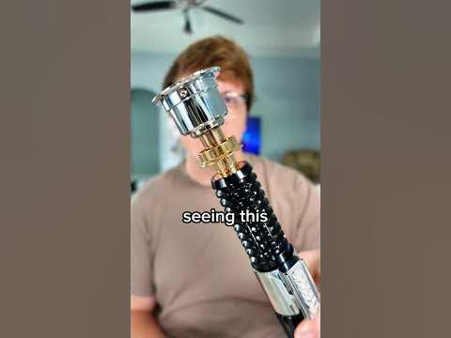  
  
<https://youtube.com/shorts/HBctRjNHfxI?feature=share>  
  
  
  
  
Chop Suey! isolated vocals by Serj Tankian and Daron Malakian of System of a Down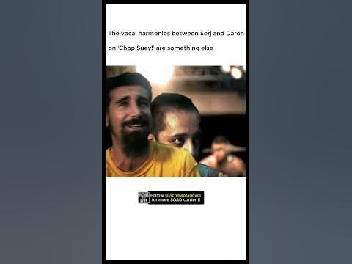  
  
<https://youtube.com/shorts/K9v2TBCnaMw?feature=share>  
  
  
  
  
(BETTER QUALITY!) Living Colour performing "Cult Of Personality" on Arsenio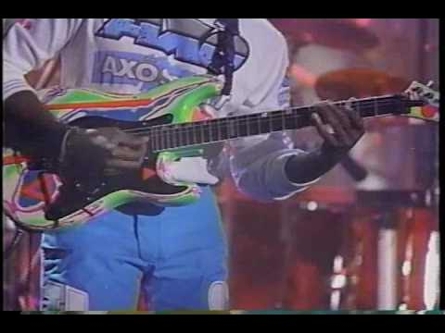  
  
<https://youtu.be/j74mxqvxRDQ>  
  
  
  
  
Why are you gay? Interview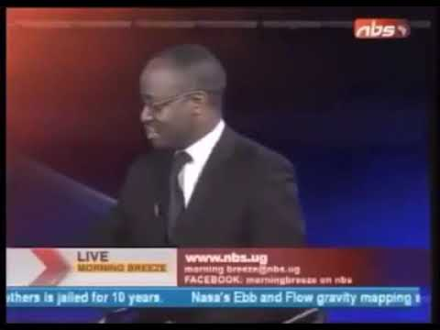  
  
<https://youtu.be/paq6sVkkEg0>  
  
  
  
  
PokeCenter theme tapped on guitar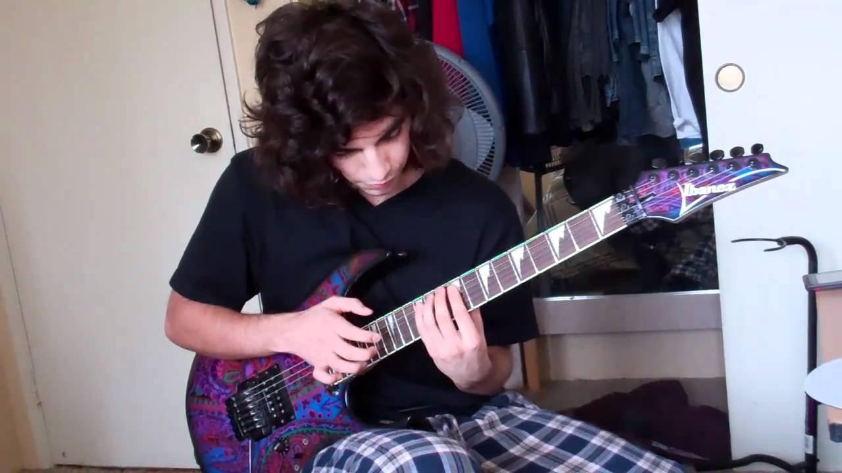  
  
<https://youtu.be/Jd7JUtrBVeU>  
  
  
  
  
John Pinette Chinese Buffet - You Been Here 4 Hour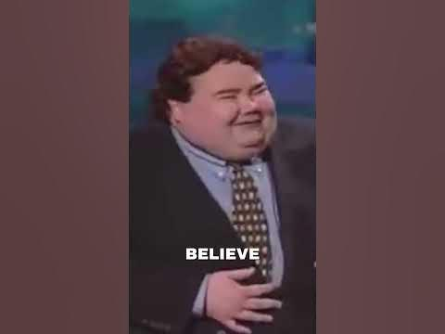  
  
<https://youtube.com/shorts/AFO9x0dwT_4?feature=share>  
  
  
  
  
ziasabers heavy dueling lightsabers-Live out Your Jedi Fantasies with ZiaSabers Lightsabers: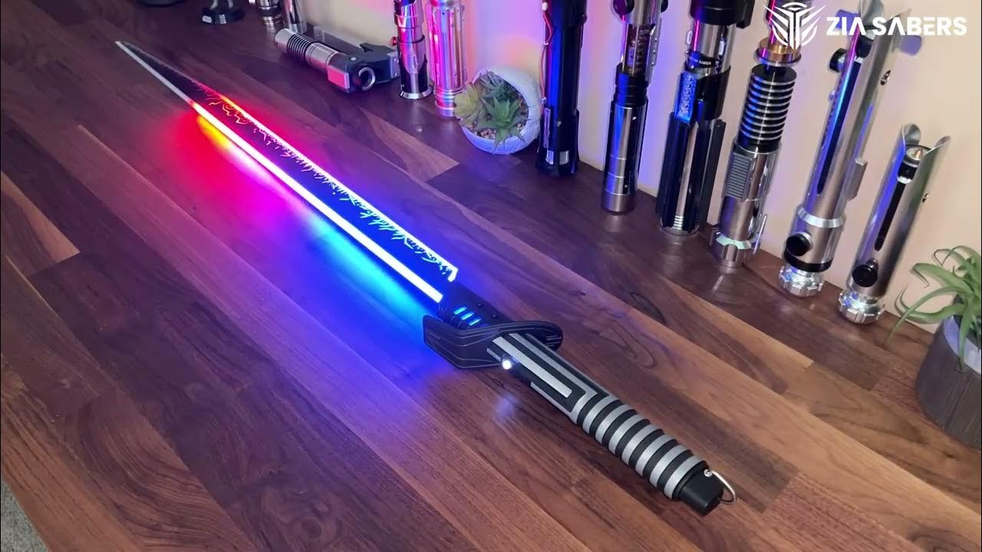  
  
<https://youtu.be/sOkZGPKpHzs>  
  
  
  
  
THE GREATEST FREUDIAN SLIP IN THE HISTORY OF THE WORLD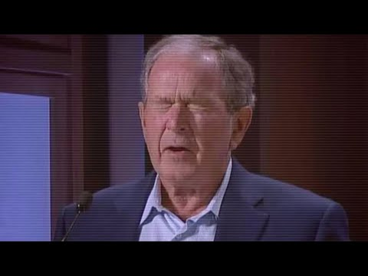  
  
<https://youtu.be/GLnbDr_OL6g>  
  
  
  
  
Chuck Norris stops a chainsaw bare handed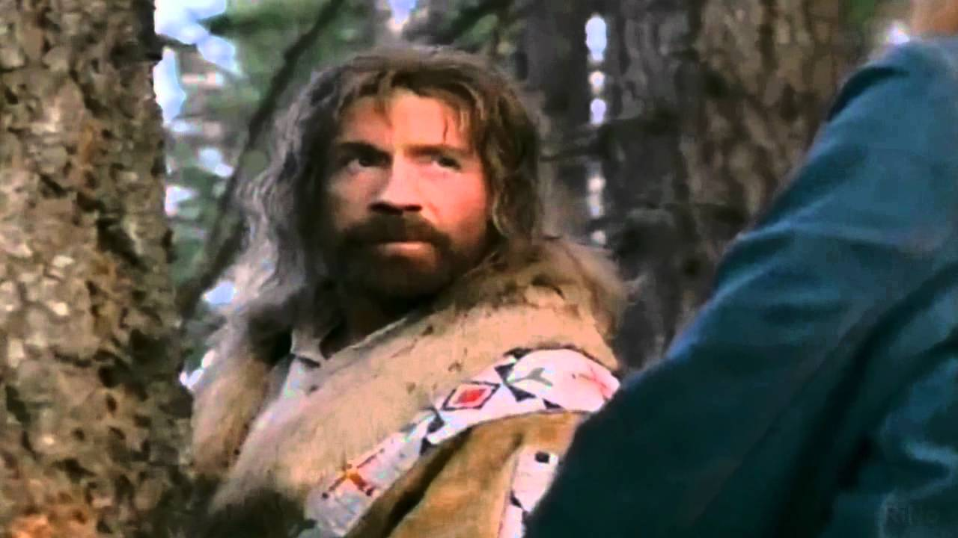  
  
<https://youtu.be/fdwC4vhc594>  
  
  
  
  
Bare Knuckle fighters are built DIFFERENT (@BareKnuckleNews /@BKFC )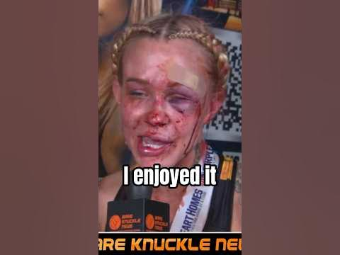  
  
<https://youtube.com/shorts/RbAcfIWQZIo?feature=share>  
  
  
  
  
Death Metal Drumming Washing Machine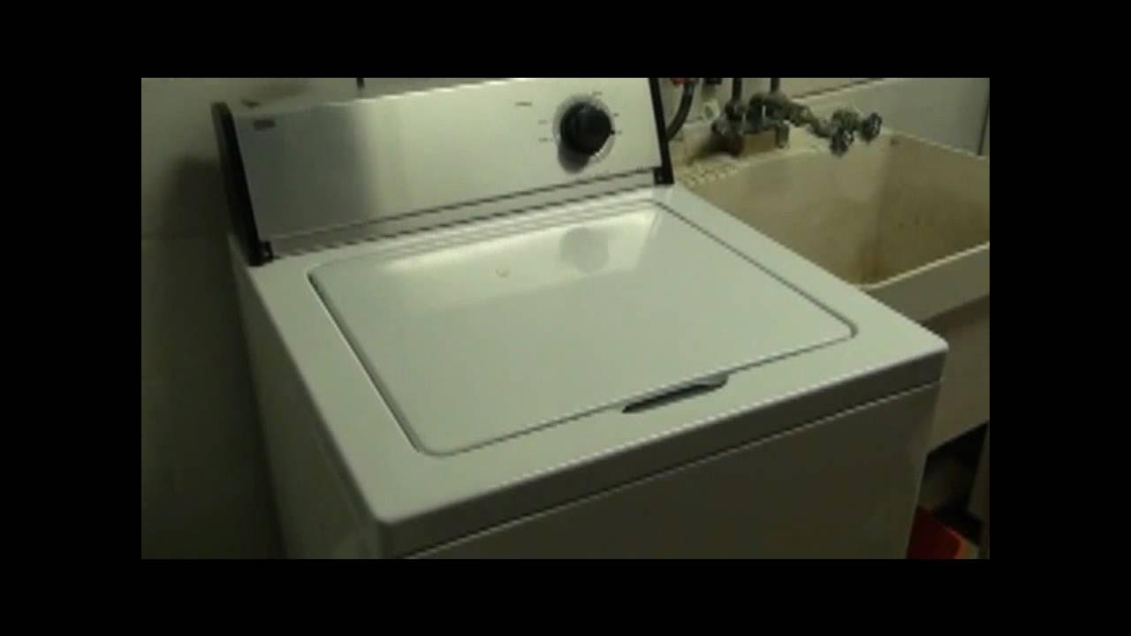  
  
<https://youtu.be/dAXa3wTZjes>  
  
  
  
  
Everything has changed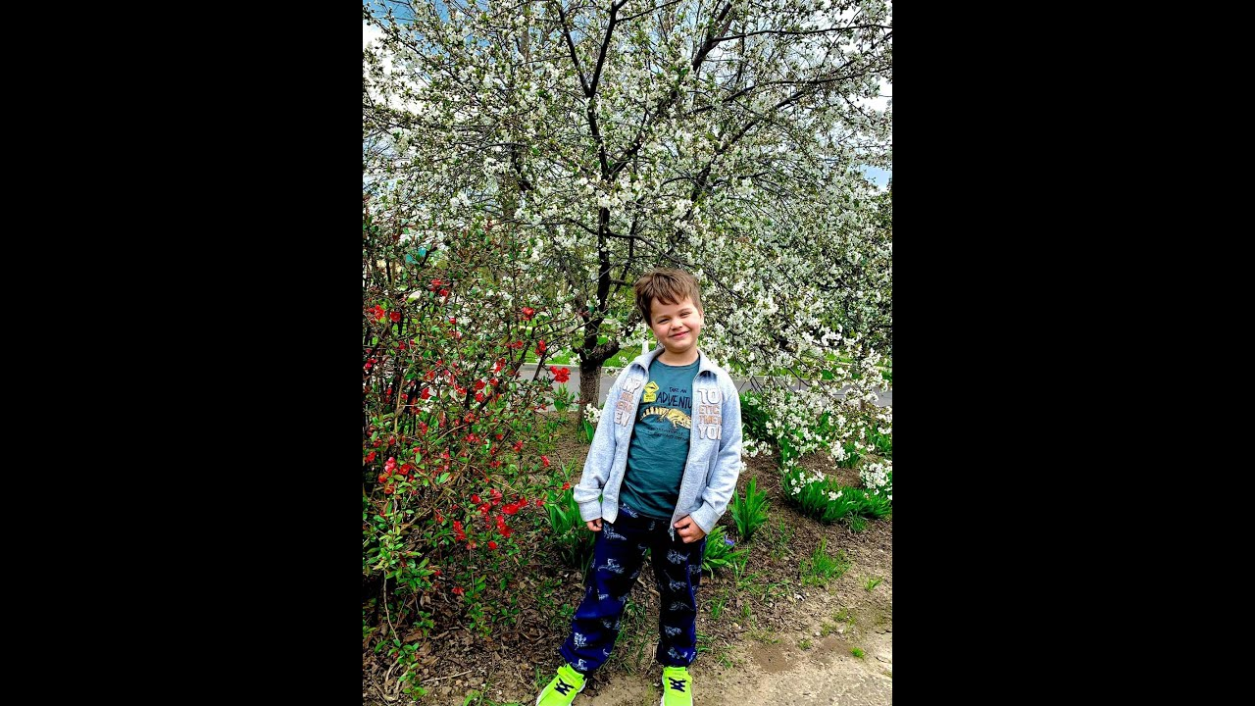  
  
<https://youtu.be/iEHbZU9G5Eo>  
  
  
  
  
I Gave Her A $1,000 Tip #Shorts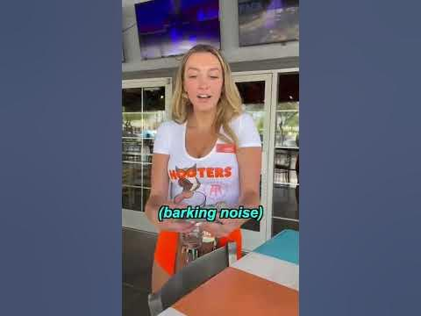  
  
<https://youtube.com/shorts/fcWh5iPr6Z0?feature=share>  
  
  
  
  
a rare sighting of me getting my choreo on the first take 😆 #behindthescenes #jumprope #skipping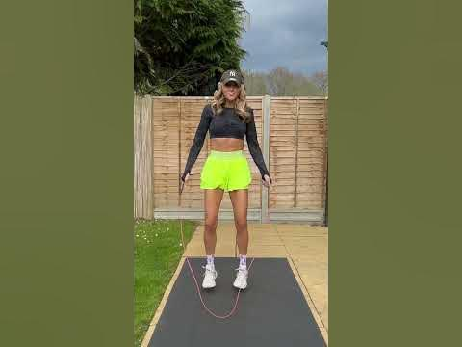  
  
<https://youtube.com/shorts/Ti-9q00ljqw?feature=share>  
  
  
  
  
The Most Brutal Beating To A Woman In WWE History That Even Shocked The Fans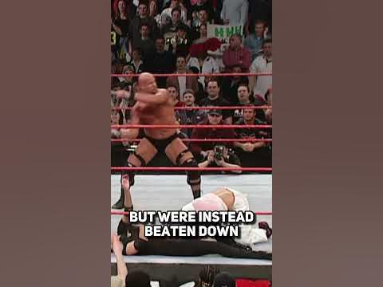  
  
<https://youtube.com/shorts/My9OYi1PciE?feature=share>  
  
  
  
  
Would You Try Deathdiving?!😱 #shorts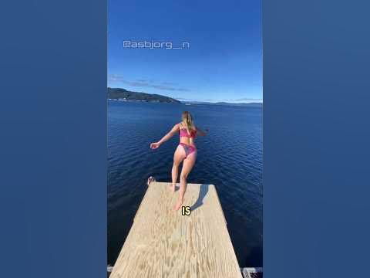  
  
<https://youtube.com/shorts/MbwTV4Tj_6o?feature=share>  
  
  
  
  
no way my mom just did this dance #youtube #dance #mom #family #familydance #funny #bestie #ootd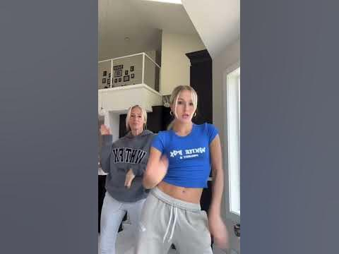  
  
<https://youtube.com/shorts/2QsV8i4o-5o?feature=share>  
  
  
  
  
Jim Carrey's "daughter" looks and acts just like him!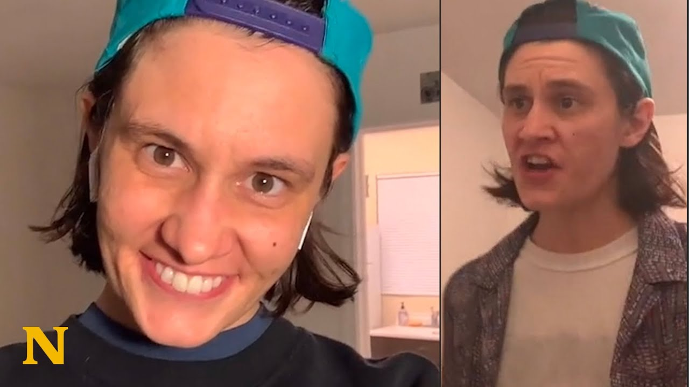  
  
<https://youtu.be/S-WRoFRiFN0>  
  
  
  
  
Wearing 🍑 shorts infront of my husband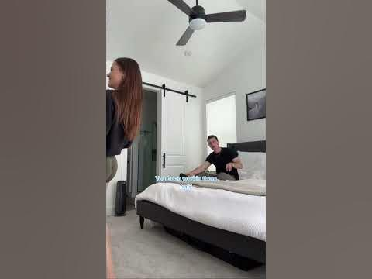  
  
<https://youtube.com/shorts/tFfwYjd0m8c?feature=share>  
  
  
  
  
Two Innocent Girls Turn Into FREAKS!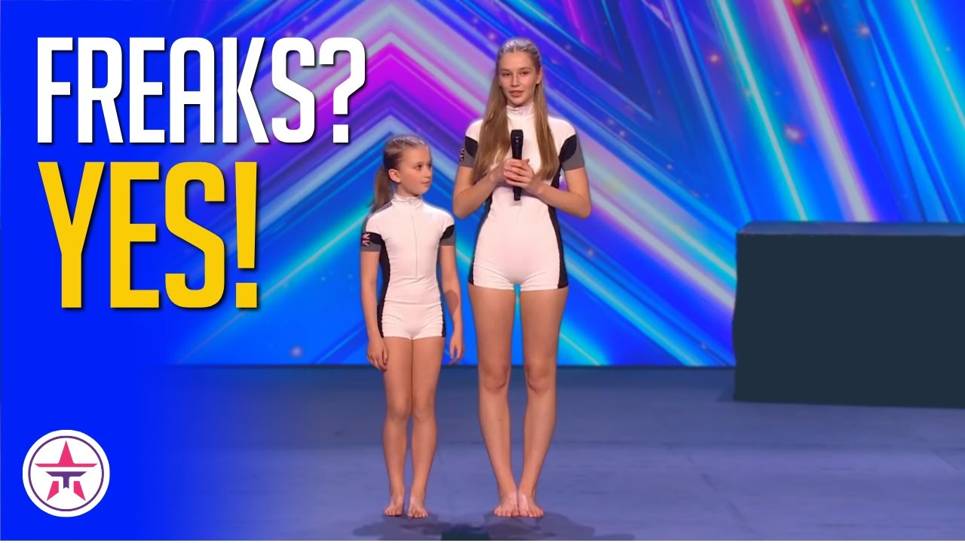  
  
<https://youtu.be/t0914_jE-ks>  
  
  
  
  
when u still use ur high school email #shorts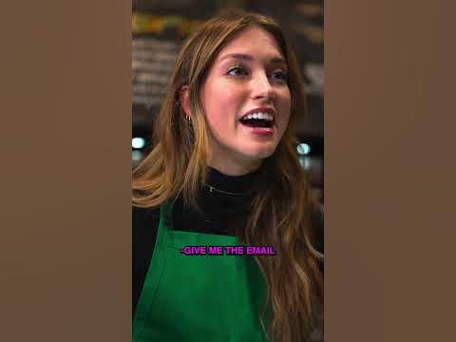  
  
<https://youtube.com/shorts/QxW5zZTCIIM?feature=share>  
  
  
  
  
Offering UFC fighters beer after they fight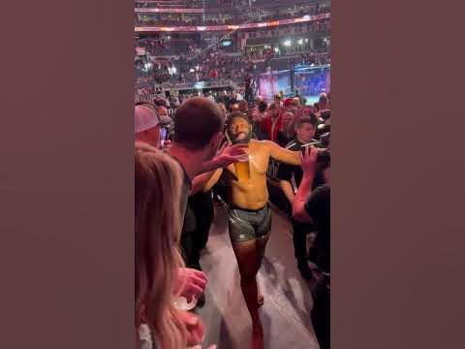  
  
<https://youtube.com/shorts/p0G-znA7LeQ?feature=share>  
  
  
  
  
Storyteller Tactics  
  
<https://pipdecks.com/pages/storyteller-tactics-card-deck>  
  
  
  
  
Say Goodbye to Smelly Fritos Paws: Sleepy Cotton's Paw Gel Cleanser Review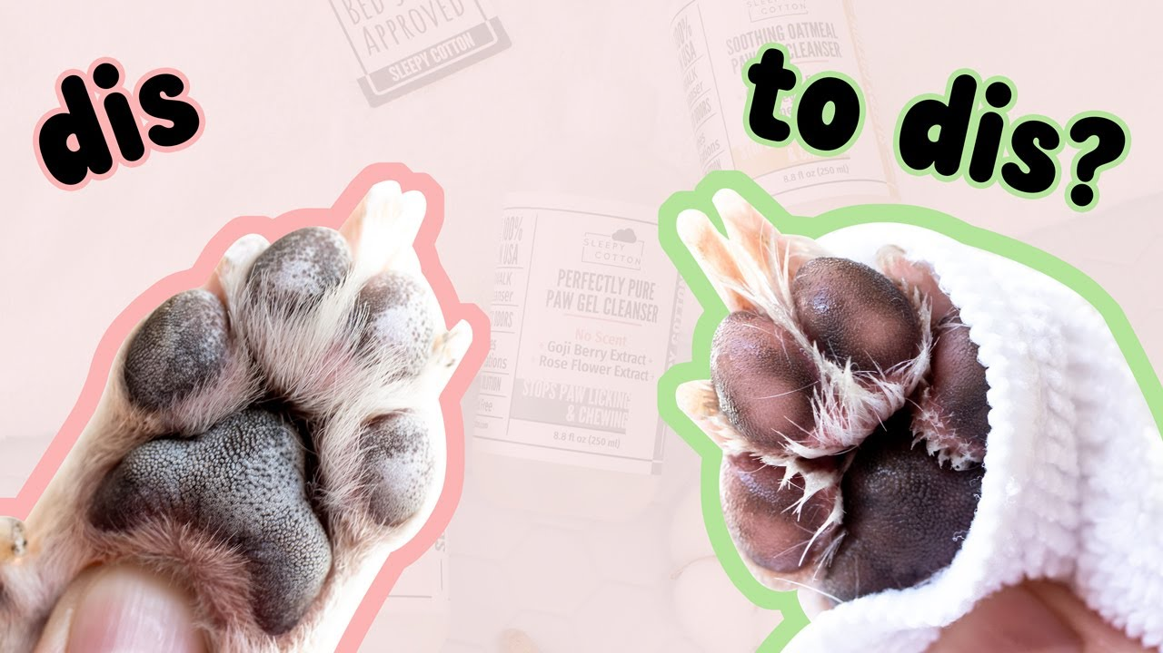  
  
<https://youtu.be/qWNA4JWq0oo>  
  
  
  
  
TIMES THAT ACTORS BROKE CHARACTER! #shorts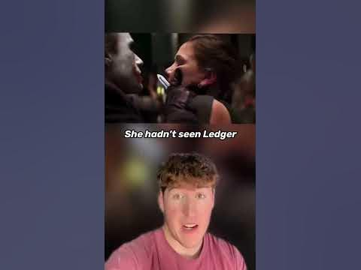  
  
<https://youtube.com/shorts/35YWFQnqBjs?feature=share>  
  
  
  
  
Freddie Mercury AI - I Will Always Love You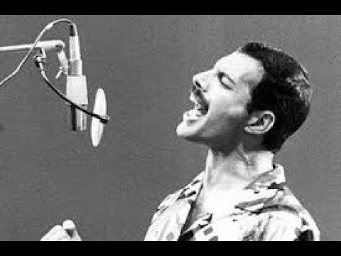  
  
<https://youtu.be/zDaTFLweCcs>  
  
  
  
  
Anne Hathaway gets offended during interview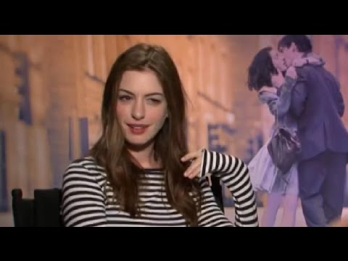  
  
<https://youtu.be/S3-5e0OOLKQ>  
  
  
  
  
15 Weirdest WWE Matches Ever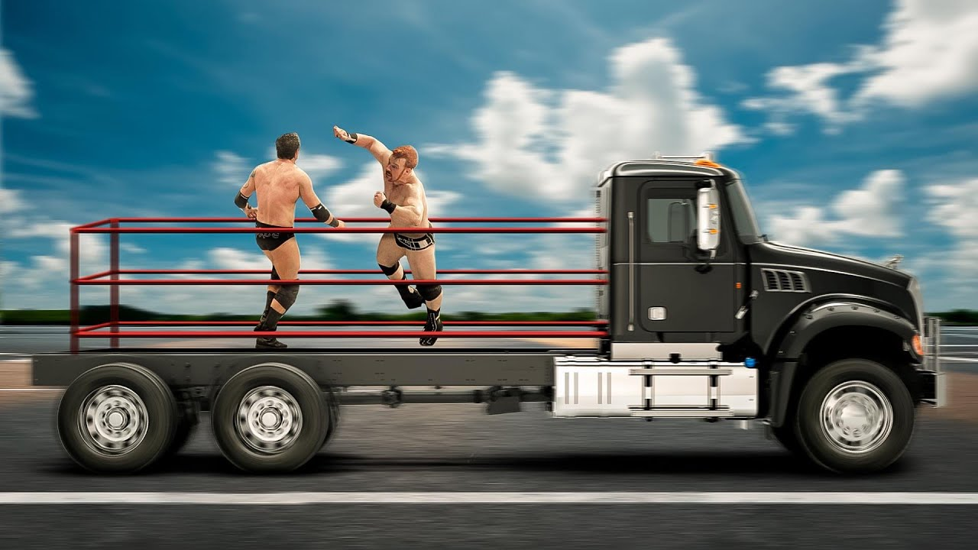  
  
<https://youtu.be/oe9mWZcW9j8>  
  
  
  
  
Bart Simpson Drum Solo Transcription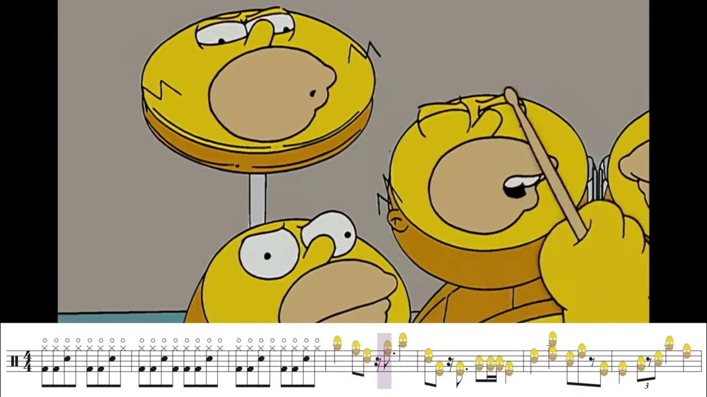  
  
<https://youtu.be/Q2xhvasIVb8>  
  
  
  
  
when you’re overqualified for the job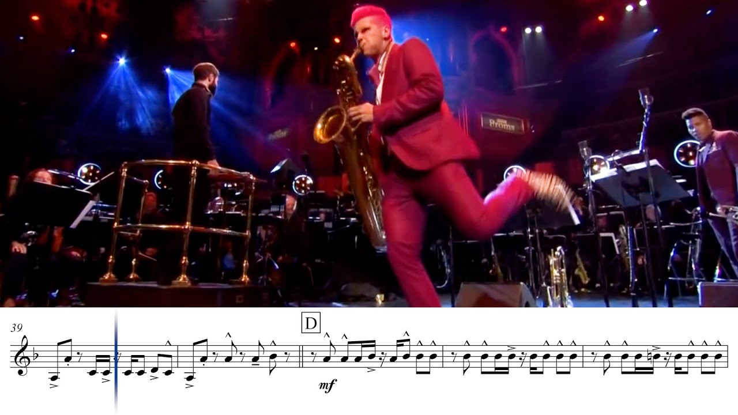  
  
<https://youtu.be/lp5PwrOshgE>  
  
  
  
  
Bertrand Russell - Message To Future Generations (1959)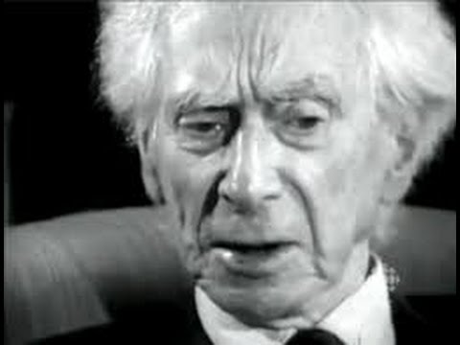  
  
<https://youtu.be/ihaB8AFOhZo>  
  
  
  
  
My Ass Is Gay (Ace Of Spades Motorhead parody, this is comedy with an important message)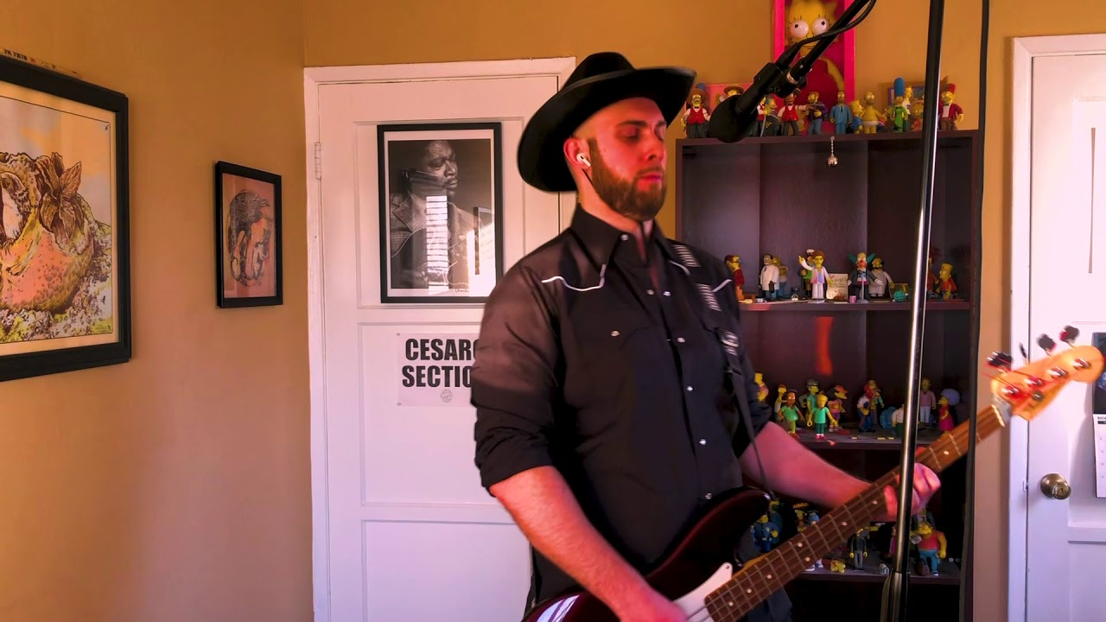  
  
<https://youtu.be/0j7qzRqYCkk>  
  
  
  
  
How to Pronounce ( ͡° ͜ʖ ͡°)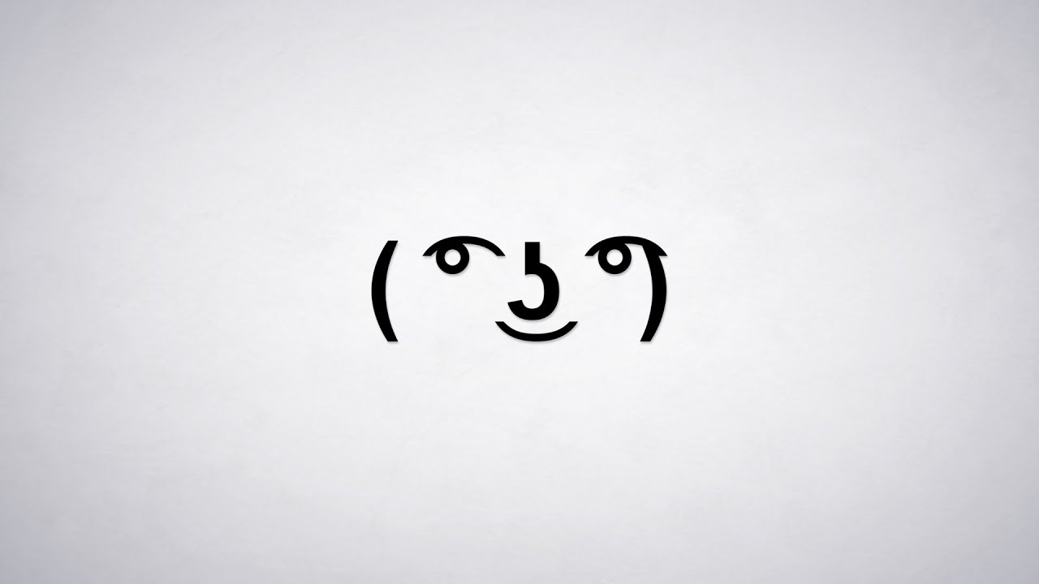  
  
<https://youtu.be/hPq54gxHAFU>  
  
  
  
  
The "Mario Kart" Lick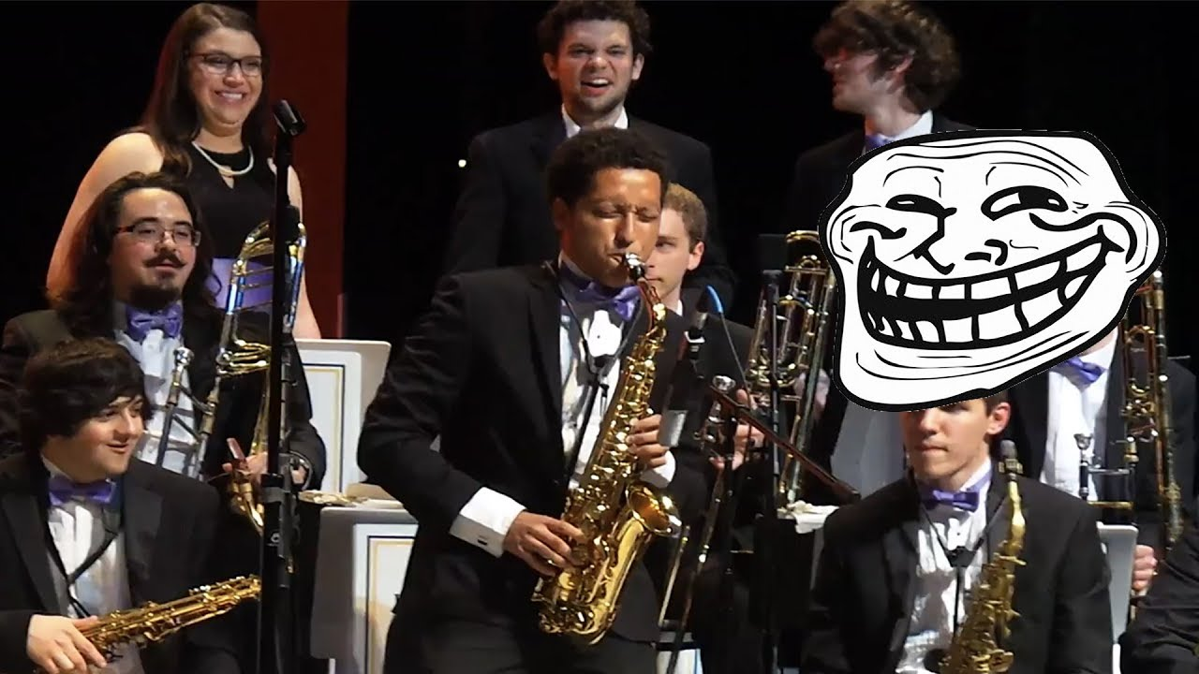  
  
<https://youtu.be/3rD-tdEFKlg>  
  
  
  
  
SMART Parody of Psychosocial by Slipknot (James Corden, please have me on Carpool Karaoke!)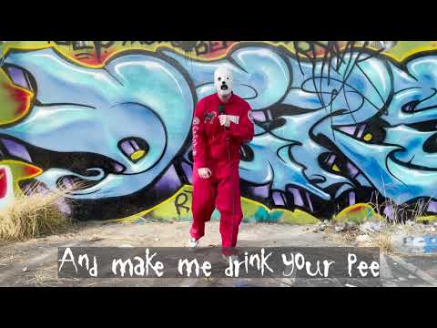  
  
<https://youtu.be/at2BufPf6bo>  
  
  
  
  
Eminem Destroys The Biggest Magazine Of All-Time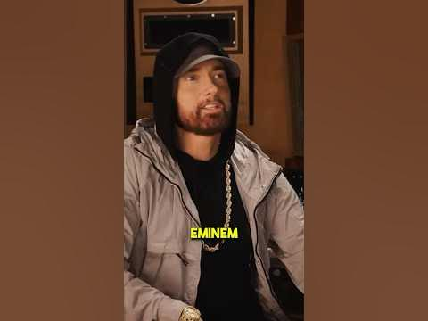  
  
<https://youtube.com/shorts/YXtTPTd1nhc?feature=share>  
  
  
  
  
my favorite nirvana moments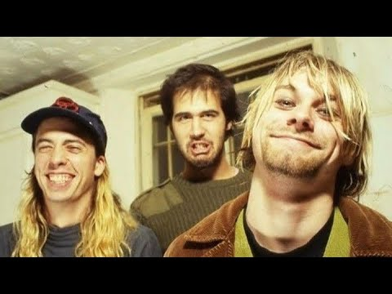  
  
<https://youtu.be/NgIxhw22qbo>  
  
  
  
  
Nirvana - 8/24/91 - Cologne, Germany - [Remastered] - [50fps] - [DAT-Audio] - Tanzbrunnen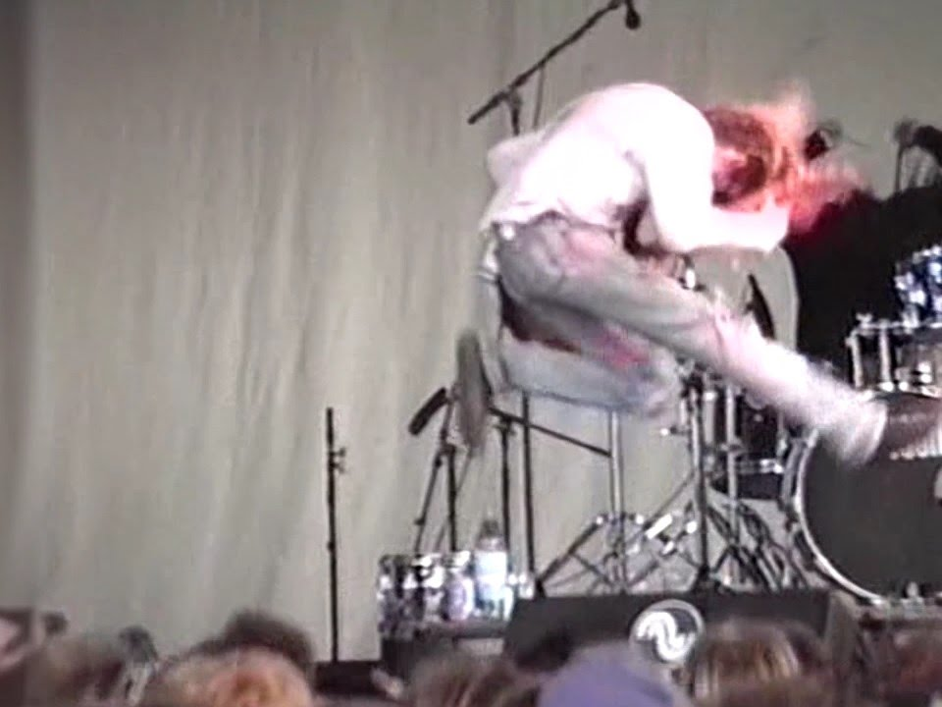  
  
<https://youtu.be/RKtAJfY_ibY>  
  
  
  
  
Failed Cash-In-Transit Heist Because Driver Has Balls Of Steel  
  
<https://youtu.be/KAvqDF3Wujc>  
  
  
  
  
New Years Watch-Party: Nirvana [Kurt Cam]- 1993-12-13 - Seattle, WA - [Kurt Solo Cam/OpenMic Audio]  
  
<https://youtu.be/LwmKySGL68k>  
  
  
  
  
Meteora Full Album - Linkin Park - 8 bit Edit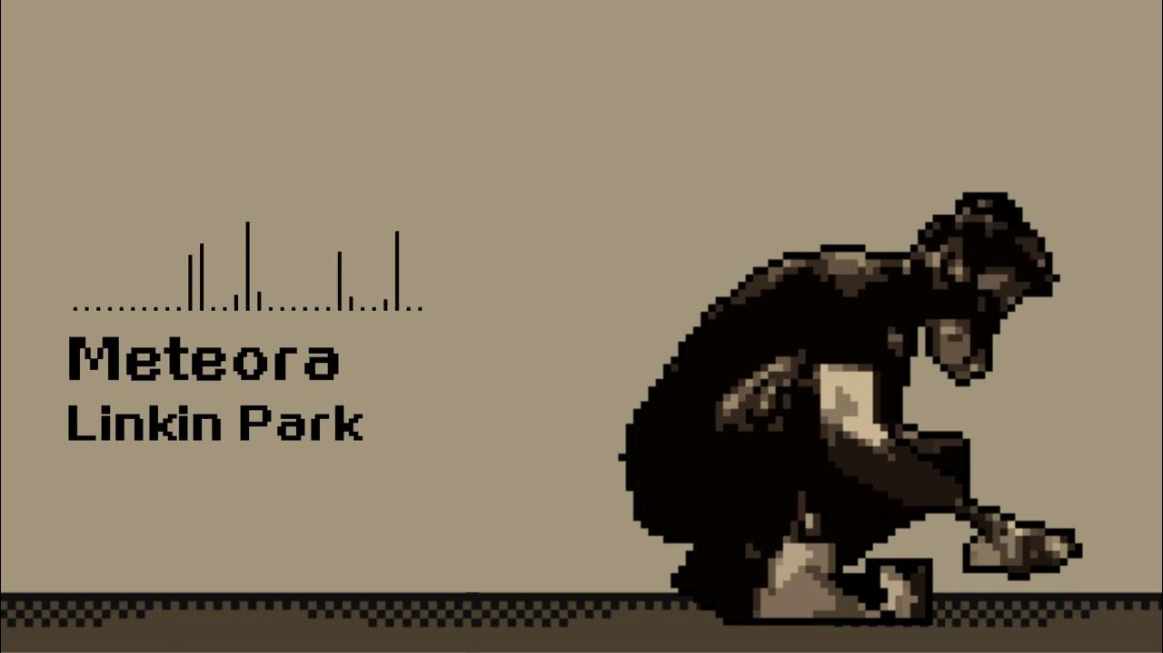  
  
<https://youtu.be/XLR3-wbITqg>  
  
  
  
  
Kajabi: Create and sell online courses, coaching, and memberships  
  
<https://kajabi.com/?g_acctid=426-534-7195&g_adtype=account&g_campaign=Youtube%20-%20NA%20-%20Video%20Action%20-%20Blended&g_campaignid=20127418042&g_adgroupid=152044536707&g_adid=658296346470&g_keyword=&g_keywordid=&g_adtype=&g_merchantid=&g_productchannel=&g_productid=&g_partition=&g_network=ytv&g_ifproduct=&g_ifcreative=&g_locinterest=9004262&g_locphysical=9004262&g_placement=youtube.com&g_network=ytv&g_device=m&utm_source=google&utm_medium=paid-youtube&utm_campaign=non_brand_na_youtube_rmk_rmk&utm_term=youtube.com&utm_content=658296346470&wbraid=ClIKCQjwkeqkBhC5ARJBAN8XXov33-g3FqHjBhjIBbsmQJifsrT8iC6IFTmNiVknkGn2QZLfrLDH_3ru7CM3fOrS0AwKEwnUCbfe5GRKB0oaArBv&wbraid=ClIKCQjwkeqkBhC5ARJBAN8XXov33-g3FqHjBhjIBbsmQJifsrT8iC6IFTmNiVknkGn2QZLfrLDH_3ru7CM3fOrS0AwKEwnUCbfe5GRKB0oaArBv>  
  
  
  
  
ONLINE FREE REGISTRATION -  
  
<https://www.pacificrimathletics.com/online-reg/?wbraid=ClIKCQjwkeqkBhC5ARJBAN8XXosQRpwRKuzybS-Wdb7o1XpaCbqYFVossRdC9bwSOXYGzRkvkBxz7g-tjXBPS4P2Mddj05Rj-QV5cW6Pzg4aAlxi&gc_id=15065471751&h_ad_id=586380330691>  
  
  
  
  
Kurt Cobain (ai generated) sings A Thousand Miles by Vanessa Carlton #ai #aimusic #grunge #nirvana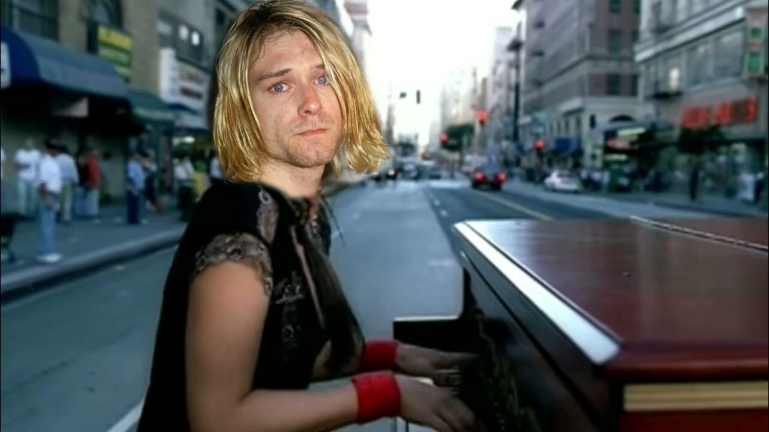  
  
<https://youtu.be/CNYMTEQBPek>  
  
  
  
  
Chris Benoit 1st Custom Titantron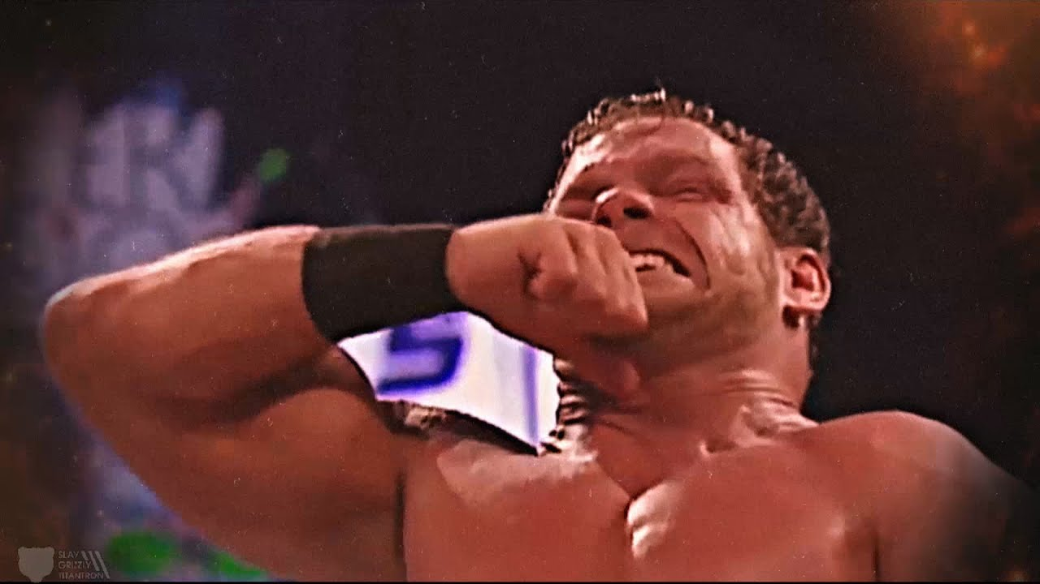  
  
<https://youtu.be/EyjZNBbcxh8>  
  
  
  
  
Heath Ledger talks about playing The Joker  
  
<https://youtu.be/WlwtHeG-LWU>  
  
  
  
  
WWE Raw Intro from Tokyo, Japan! (2005)  
  
<https://youtu.be/JCeSahkbDWs>  
  
  
  
  
freestyling about cars until i say something gay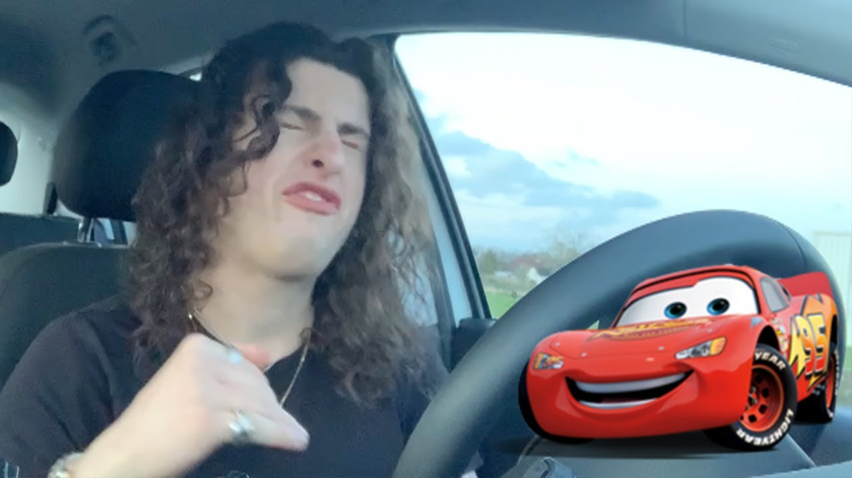  
  
<https://youtu.be/z_e7weCwimc>  
  
  
  
  
AI Chester Bennington - The Devil in I (Slipknot cover)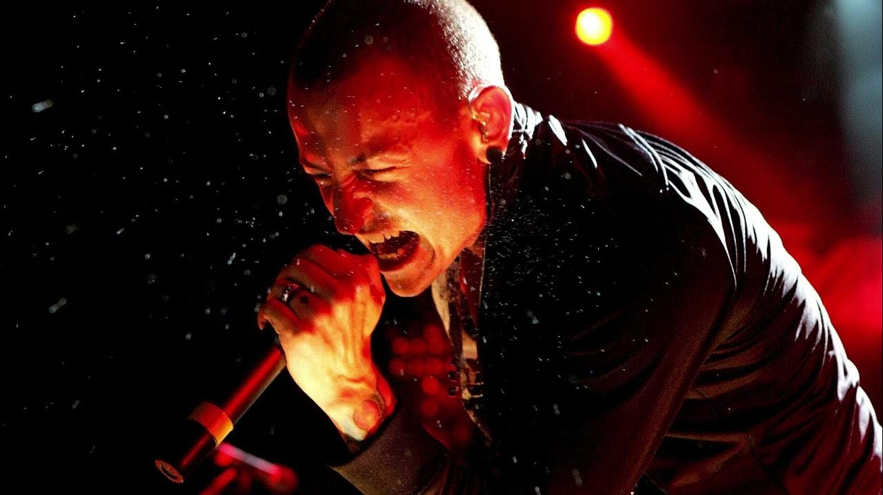  
  
<https://youtu.be/aciJefxHL_0>  
  
  
  
  
Starfire subtle as a brick  
  
<https://youtu.be/2vMv5CCF_uU>  
  
  
  
  
Guy Blows Up 300ZX trying to do Burnout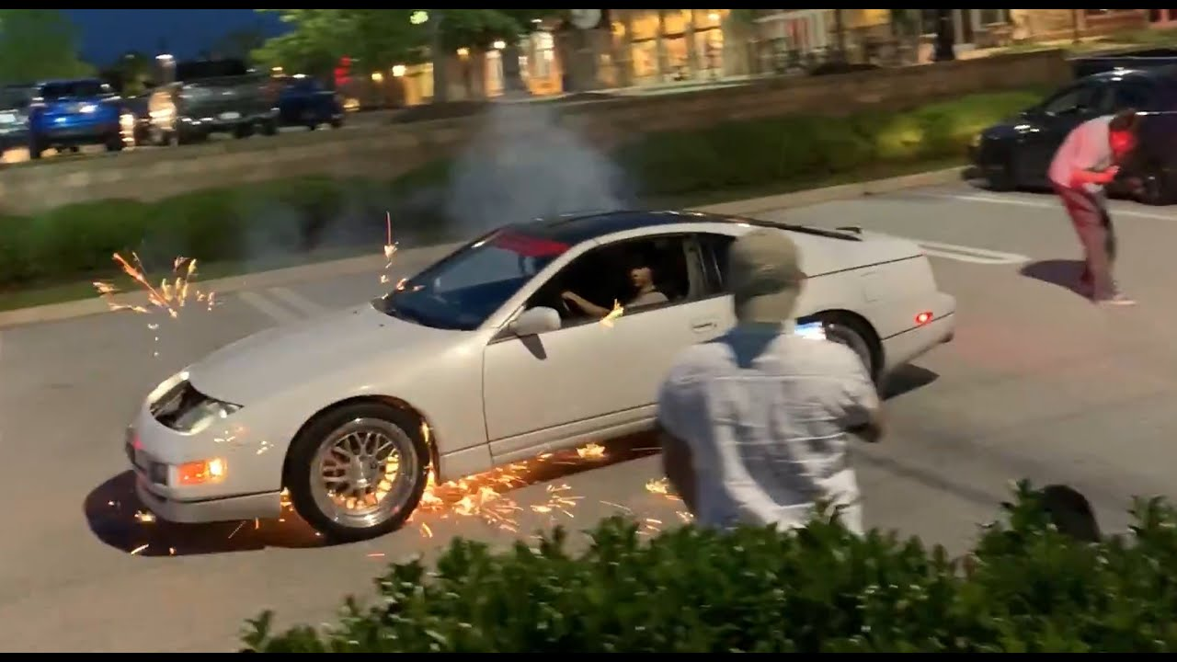  
  
<https://youtu.be/rMrNZ3WUOek>  
  
  
  
  
PREDATOR Movie Clip - You Son Of A Bitch (1987) Arnold Schwarzenegger Sci-Fi Action Movie HD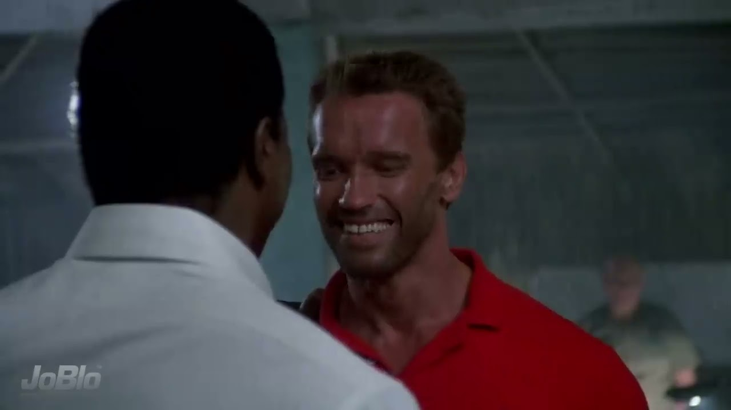  
  
<https://youtu.be/VD-fBj4d9Ck>  
  
  
  
  
Living Colour - Cult Of Personality #Woodstock2016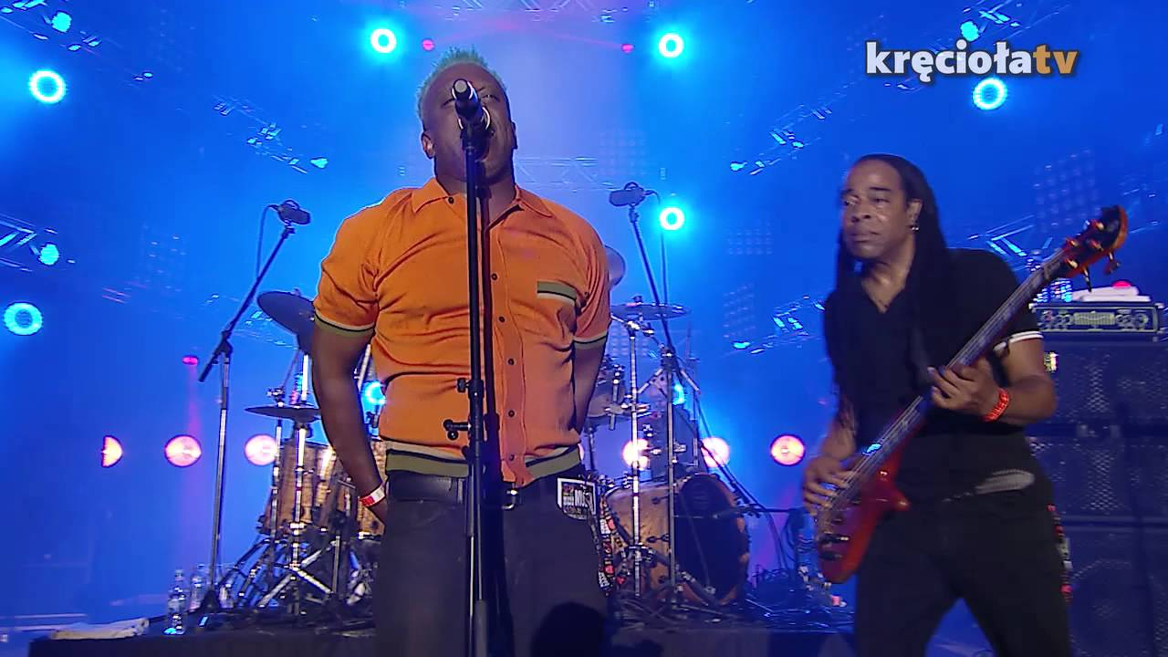  
  
<https://youtu.be/SqEWvJEy9nU>  
  
  
  
  
Brock Lesnar Gave Roman Reigns A Receipt He Will NEVER Forget 😳 #shorts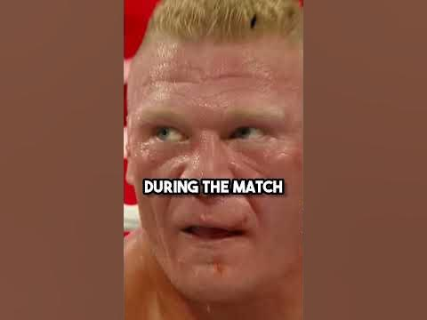  
  
<https://youtube.com/shorts/jkeC0IrsW-E?feature=share>  
  
  
  
  
Cherneka Johnson vs. Ellie Scotney - Weigh-in Face-Off - (Matchroom Boxing: Edwards vs. Campos)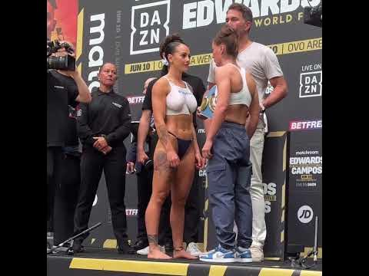  
  
<https://youtube.com/shorts/c25z82ApjOk?feature=share>  
  
  
  
  
Watching Amy Schumer until I laugh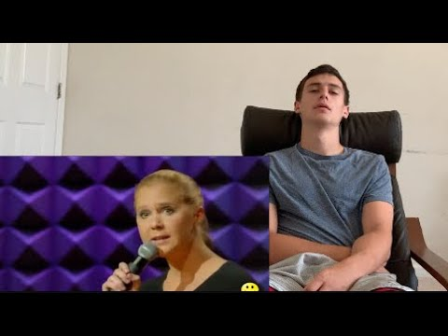  
  
<https://youtu.be/cRSkWn10T5c>  
  
  
  
  
Took Homeless Man For Lunch, Something Bad Happened to Him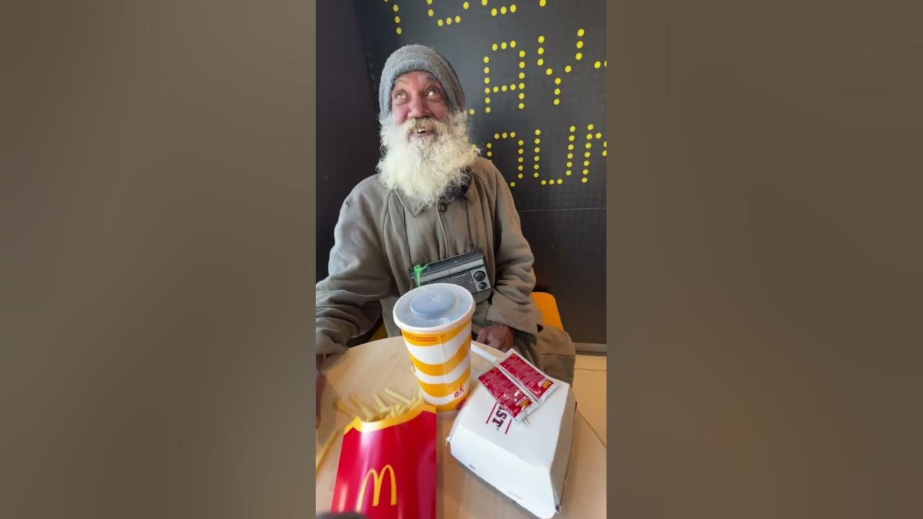  
  
<https://youtu.be/_E_8zYpgN44>  
  
  
  
  
How I blew my forearms with rice (update)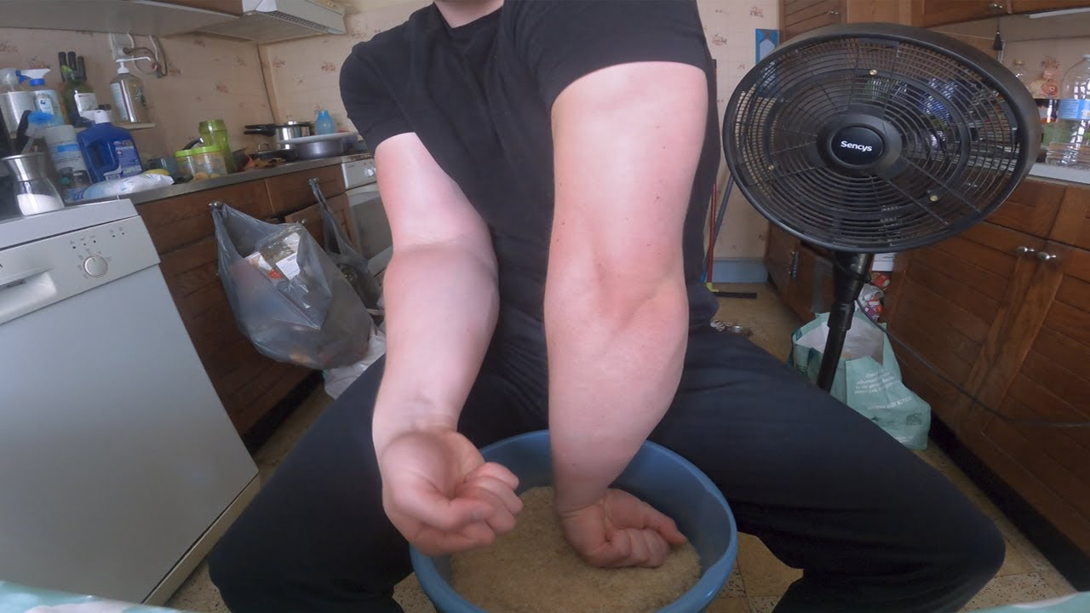  
  
<https://youtu.be/dC1peFoy3HE>  
  
  
  
  
Best Doritos Commercial Ever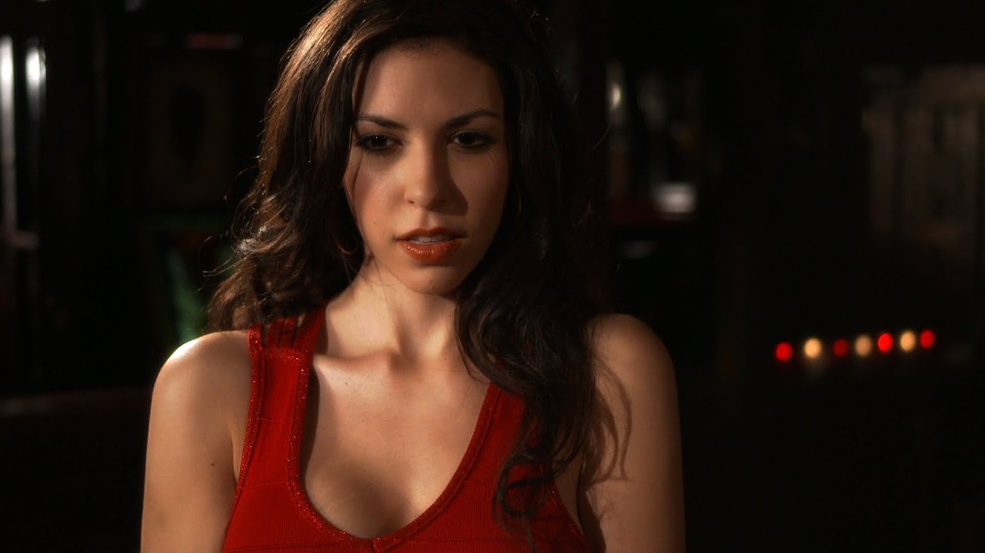  
  
<https://youtu.be/LTvpkZ0U0rM>  
  
  
  
  
"Fly Me to the Moon" with an original rap verse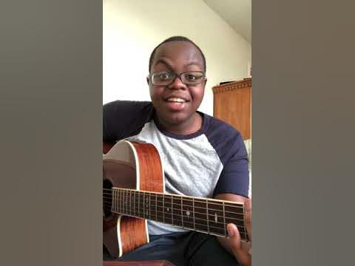  
  
<https://youtu.be/O1puRnV6gwE>  
  
  
  
  
91-year-old substitute teacher schools her students on the Charlston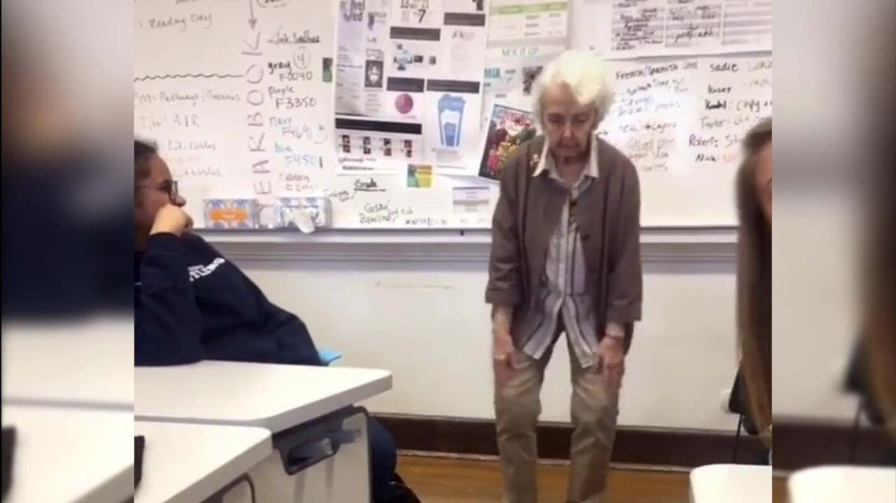  
  
<https://youtu.be/N9VhxL3NZjI>  
  
  
  
  
Eddie Guerrero Shoot Interview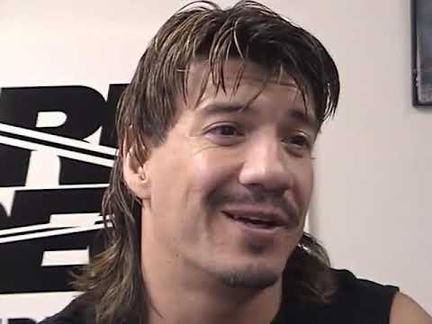  
  
<https://youtu.be/LiOqdZN0Weg>  
  
  
  
  
Every guys dream 😂 #shorts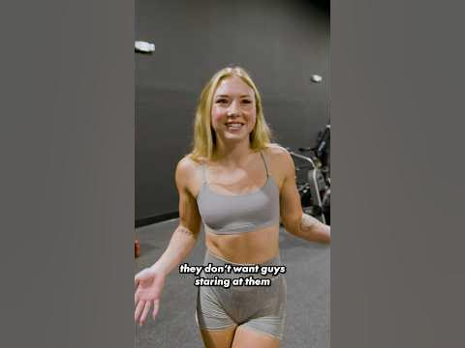  
  
<https://youtube.com/shorts/ATx-hlfK9o4?feature=share>  
  
  
  
  
Nancy Wilson demonstrates the intro to Crazy On You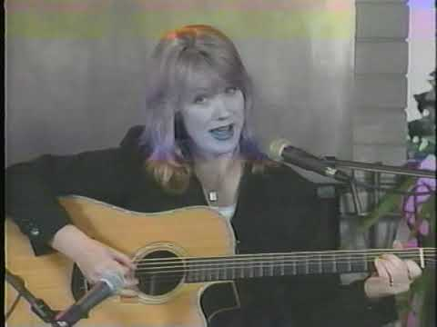  
  
<https://youtu.be/SuiDF5EX4bQ>  
  
  
  
  
It should be illegal to play this fast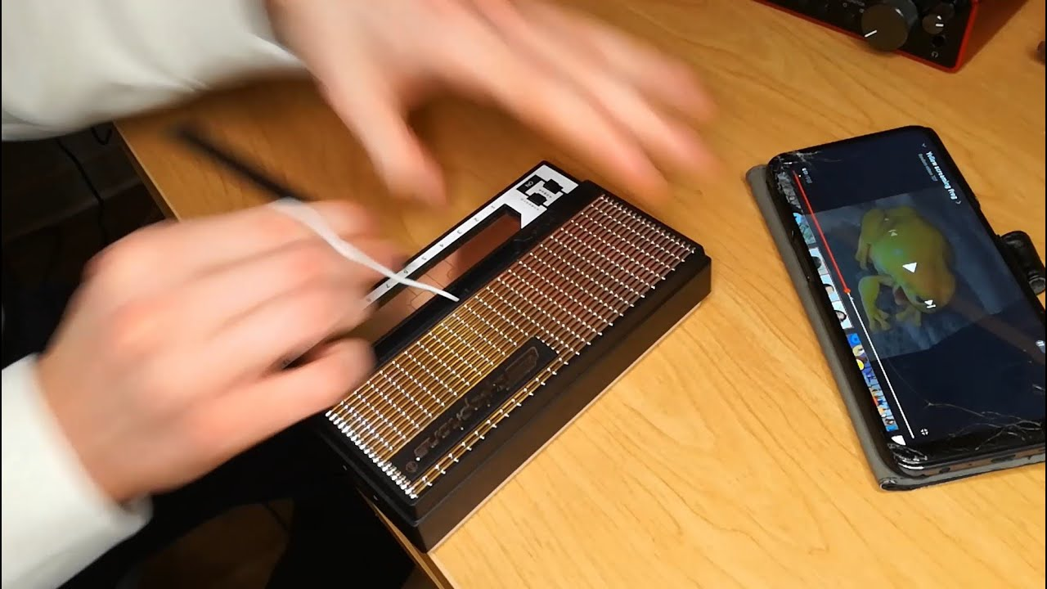  
  
<https://youtu.be/tz8hooclBRI>  
  
  
  
  
AEW Fight Forever is REALLY Fun... BUT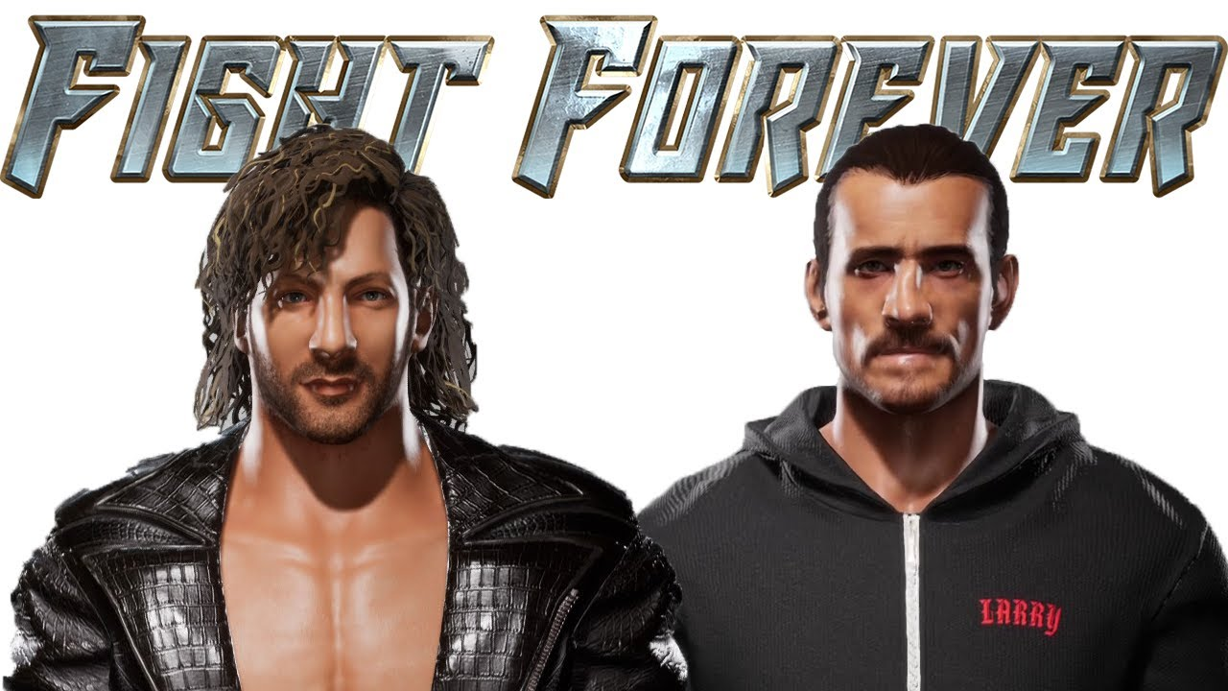  
  
<https://youtu.be/RuY9xAEQyf4>  
  
  
  
  
This Guitar is Made 100% of GLASS and Sounds BEAUTIFUL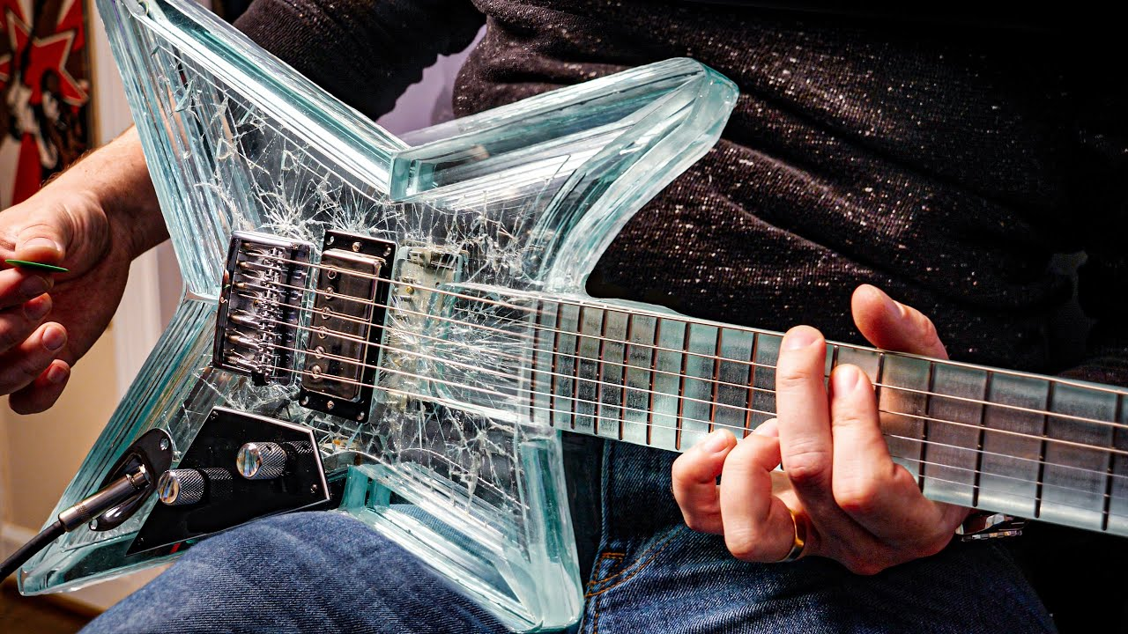  
  
<https://youtu.be/ozRldQY1PtE>  
  
  
  
  
Breakdance Top 14 Suicide Moves 2019 || Best Bboy Suicide moves || Bboying Power moves ||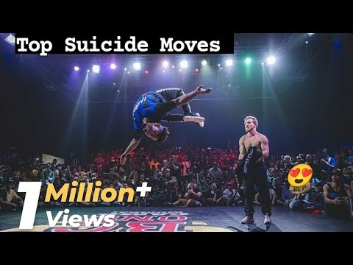  
  
<https://youtu.be/pkxqAmAL4ZQ>  
  
  
  
  
Heath Ledger's Joker without Makeup [DeepFake]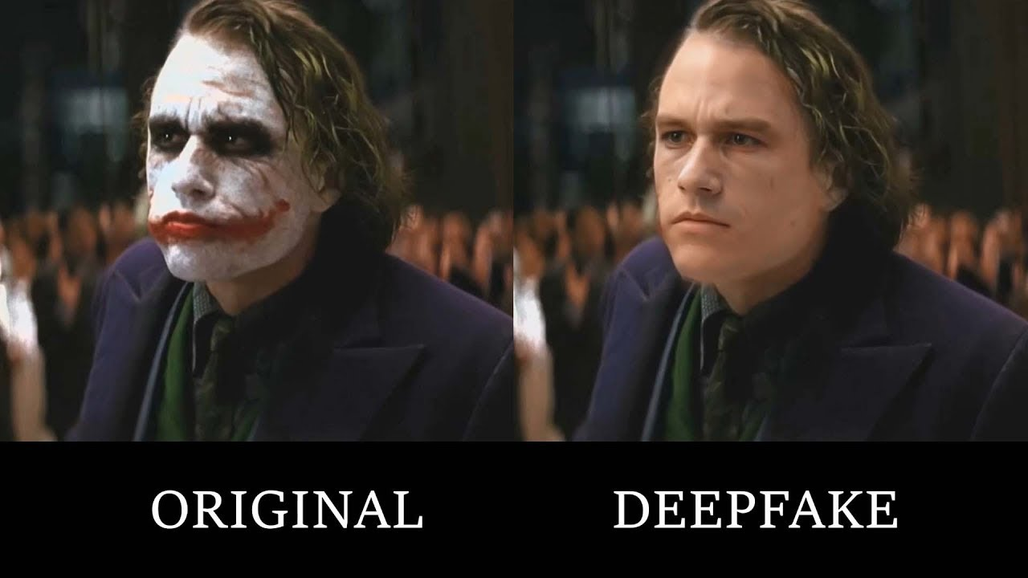  
  
<https://youtu.be/3tMEbdUspr0>  
  
  
  
  
The 1975 singer getting cut off mid sentence COMPILATION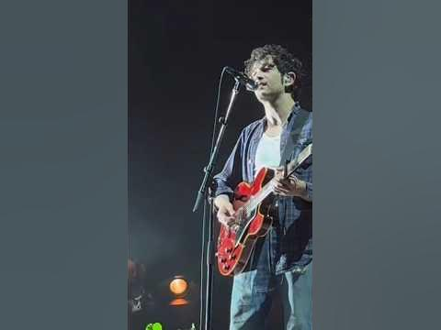  
  
<https://youtube.com/shorts/sOG-fBM9Fes?feature=share>  
  
  
  
  
Kalisto Botched interview Draft 2016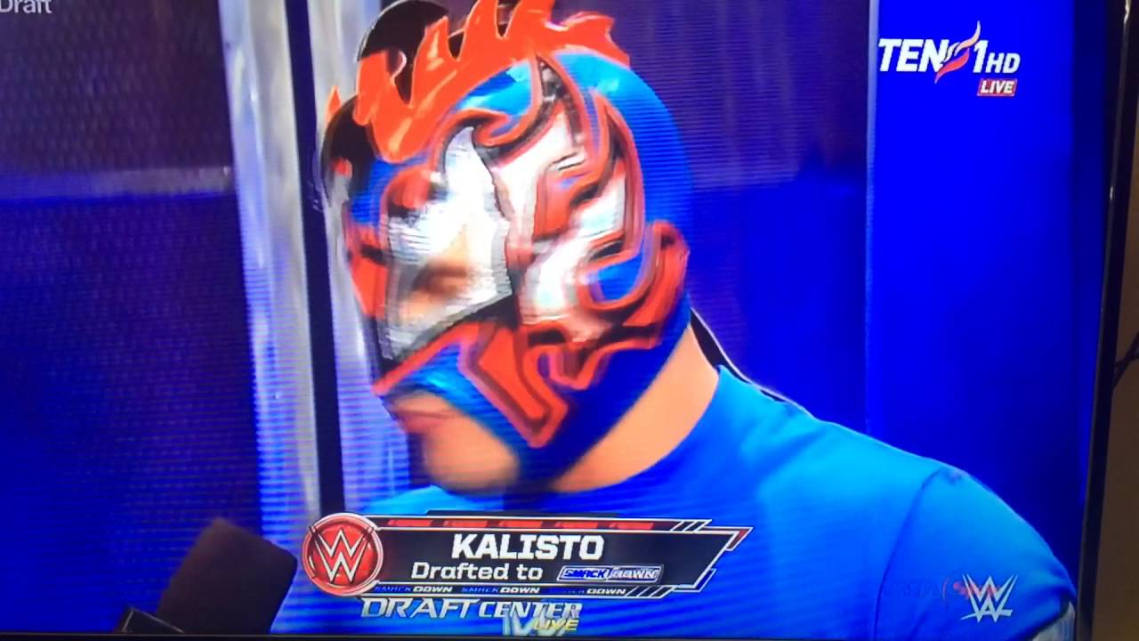  
  
<https://youtu.be/fe6KX3pkA70>  
  
  
  
  
"3 YRS AGO THAT WOULD HAVE BEEN A TRIP TO SUPLEX CITY!" BROCK LESNAR WANTS TO TAKE SAMI ZAYN FISHING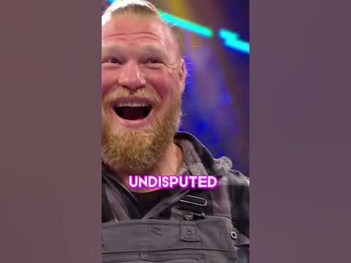  
  
<https://youtube.com/shorts/HFlac-0A2hk?feature=share>  
  
  
  
  
the gay test #shorts #comedy #funny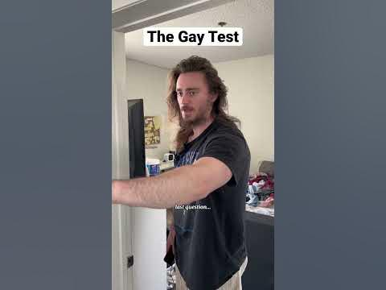  
  
<https://youtube.com/shorts/qXxC0R9CQkI?feature=share>  
  
  
  
  
Ranking Nu Metal Bands #metalhead #metal #music #rock #ranking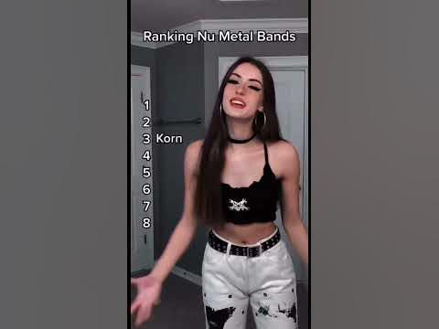  
  
<https://youtube.com/shorts/a6UI5T9e09o?feature=share>  
  
  
  
  
I Have 95% Burns - But I'm Thriving | SHAKE MY BEAUTY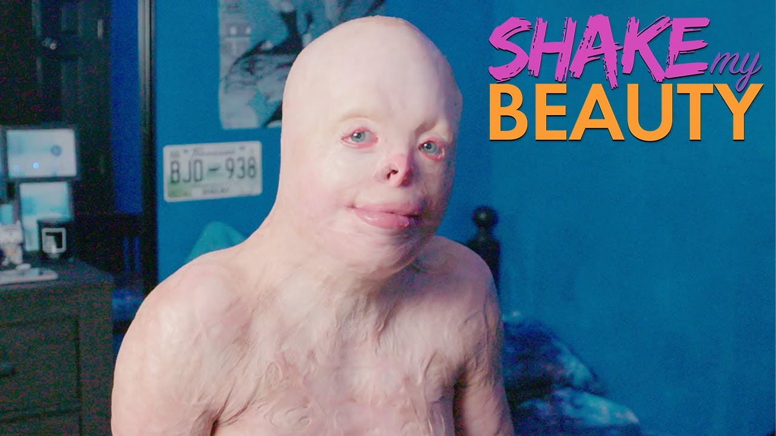  
  
<https://youtu.be/NfgtKevBPGE>  
  
  
  
  
How long do trickshots take?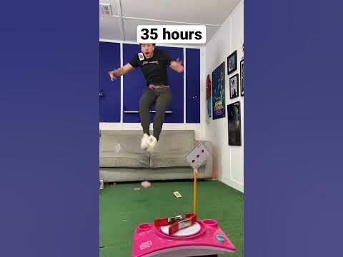  
  
<https://youtube.com/shorts/3k01apyZFlI?feature=share>  
  
  
  
  
New York ain't normal 😳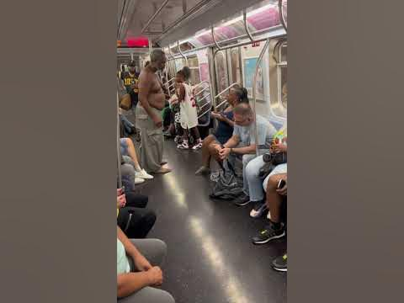  
  
<https://youtube.com/shorts/AcmcXLihbTQ?feature=share>  
  
  
  
  
Twin sister pregnant prank! #Shorts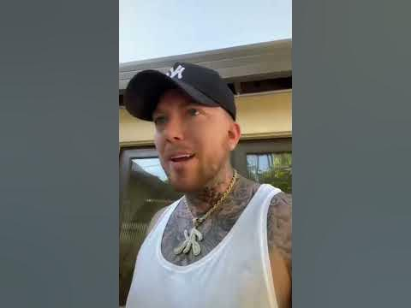  
  
<https://youtube.com/shorts/6c74XNpRdfI?feature=share>  
  
  
  
  
think we can remember these iconic dances, blindly?👀 #dance #reaction #challenge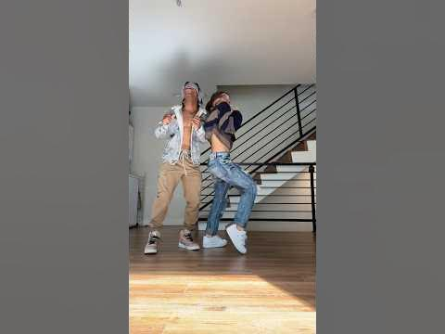  
  
<https://youtube.com/shorts/LqVeM77J7P0?feature=share>  
  
  
  
  
Shredder Machine #shorts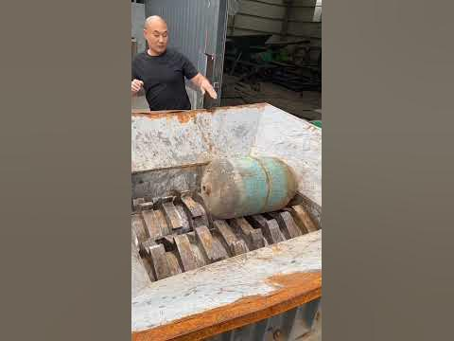  
  
<https://youtube.com/shorts/zzefjysopTs?feature=share>